1.

2.

1.

2.

3.

1.

2.
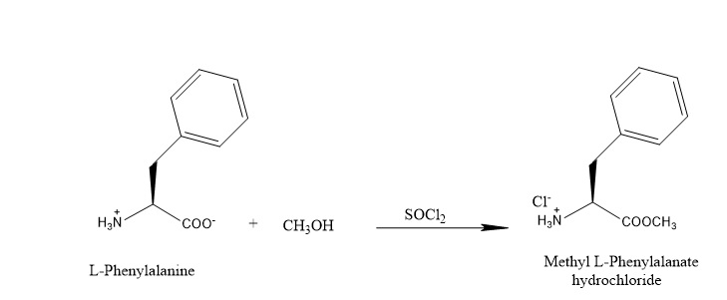

1. Formation of L-Phenylalanyl Chloride

2. Formation of the Methyl Ester

