Part 1
Relative Rates of Bromination

Phenol Anisole Diphenyl Ether Phenyl Acetate

Part 2

Aniline N-Methylaniline N,N-Diphenylamine Acetanilide

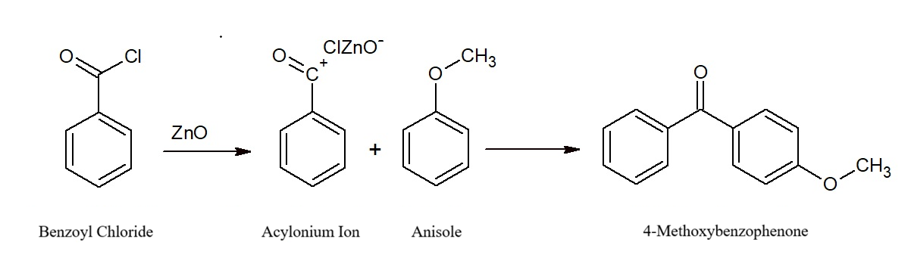
Acylation of Anisole

