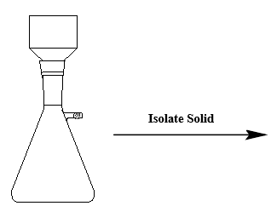

Pre-Recrystallization
Sample | MP (℃) | Mass (g)

Post-Recrystallization
Sample | MP (℃) | Mass (g)

