Nature

Synthetic

1.

2.

a.

b.

c.

Chain Reaction Example (cationic)

Nylon

Diamine Dicarboxylic Acid

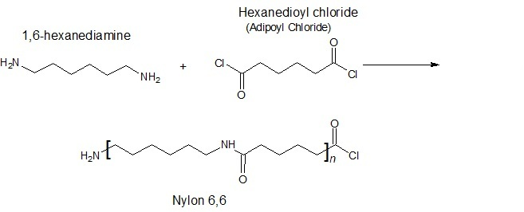
Nylon 6,6

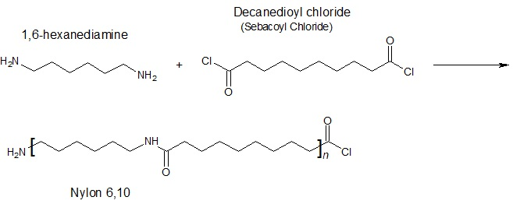
Nylon 6,10

