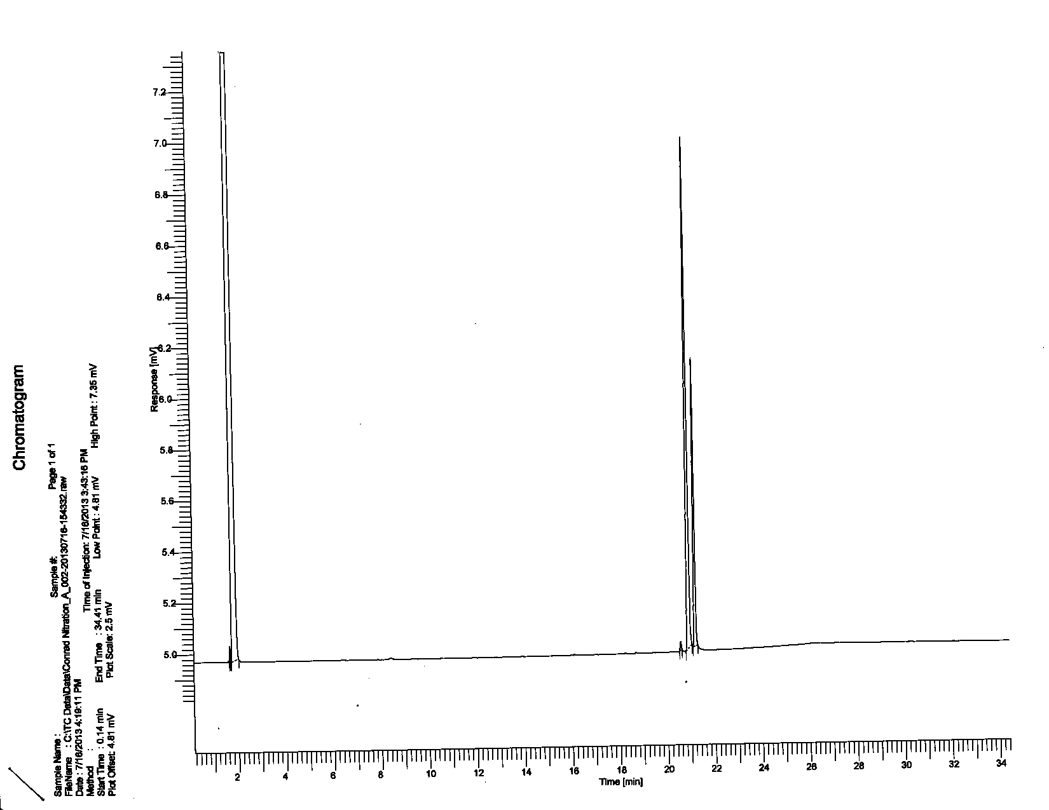**Bromobenzene**

**A**

**B**

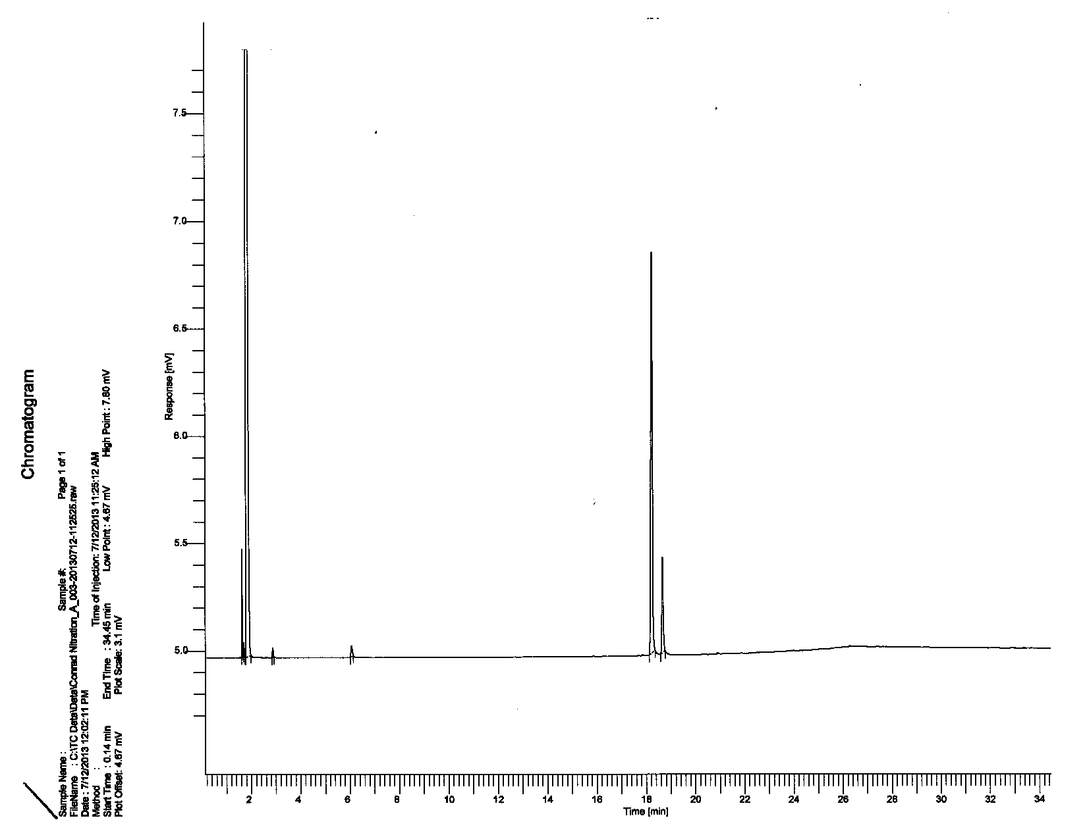**Chlorobenzene**

**B**

**A**

**Chromatogram Data**

|  |  |  |  |
| --- | --- | --- | --- |
| **Peak** | **Retention Time (min)** | **Area** | **% Area** |
| Bromobenzene A | 20.94 | 9461.45 | 69.3 |
| Bromobenzene B | 21.20 | 4183.22 | 30.7 |
| Chlorobenzene A | 18.26 | 8099.87 | 73 |
| Chlorobenzene B | 18.67 | 2995.88 | 27 |

**Relative Rates of Bromination**

|  |  |  |
| --- | --- | --- |
| Substrate (1) | Approx. time  of rxn @ 0˚ C | Approx. time  of rxn @ 35˚ C |
| Phenol | 35 sec | 1 sec |
| Anisole | 135 sec | 3 sec |
| Diphenyl ether | NR | > 5 min |
| Acetanilide | 75 sec | 20 sec |
| 4-bromophenol | 45 sec | 5 sec |