Data for Substitution

IR

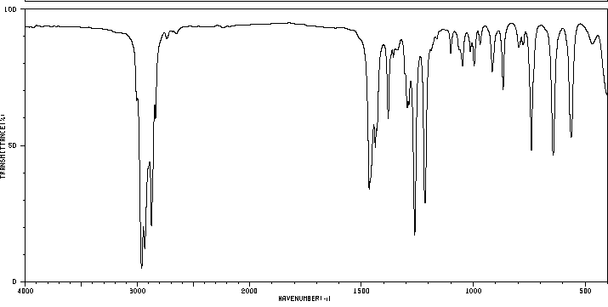

Halide Test Data

NaI Test Precip formed in 10 seconds
AgNO3 Test Precip formed in 2 minutes, 3 seconds

Yield

Weight of Product
0.31 g

