**GC Fractional Distillation Standard Data for GC #1**

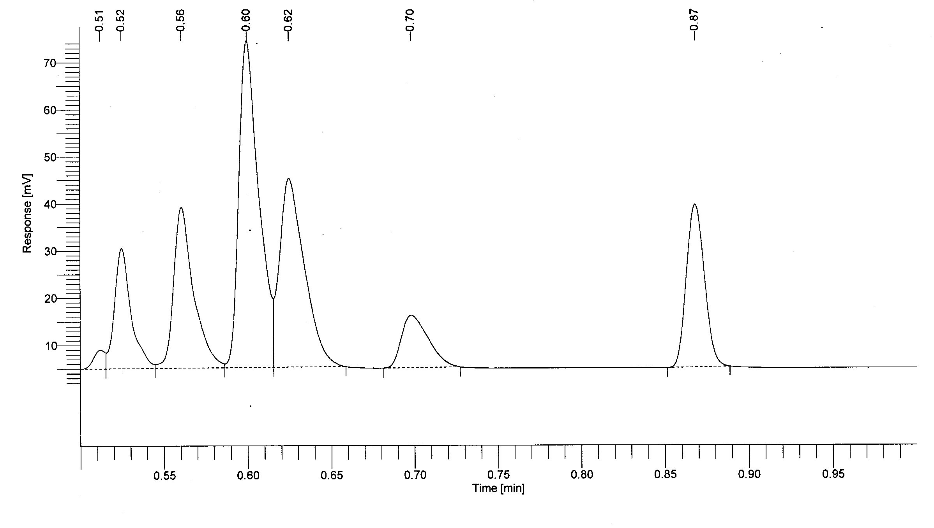

|  |  |
| --- | --- |
| **Retention Time (Minutes)** | **Compound** |
| 0.51 | Acetone |
| 0.52 | Methanol |
| 0.56 | Hexane |
| 0.60 | Cyclohexane |
| 0.62 | Heptane |
| 0.70 | Toluene |
| 0.87 | Ethylbenzene |

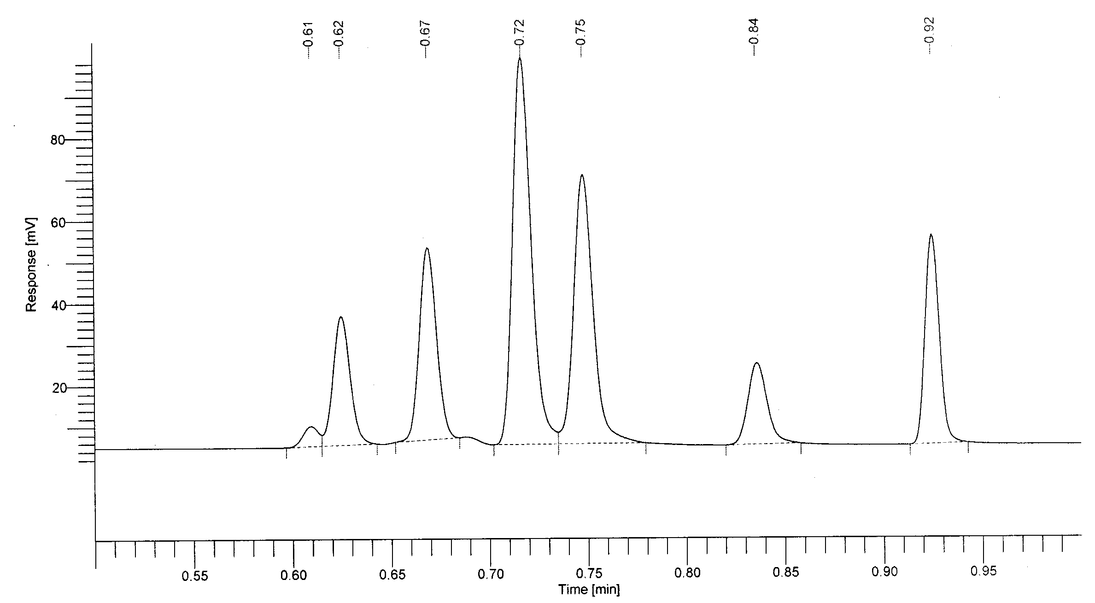**GC Fractional Distillation Standard Data for GC #2**

|  |  |
| --- | --- |
| **Retention Time (Minutes)** | **Compound** |
| 0.51 | Acetone |
| 0.52 | Methanol |
| 0.56 | Hexane |
| 0.60 | Cyclohexane |
| 0.62 | Heptane |
| 0.70 | Toluene |
| 0.87 | Ethylbenzene |

**GC Fractional Distillation Standard Data for GC #3**

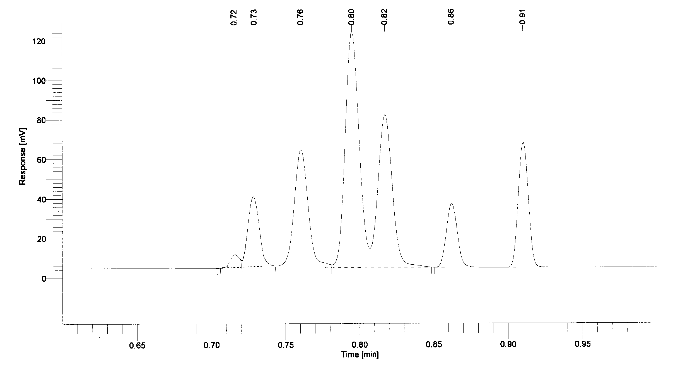

|  |  |
| --- | --- |
| **Retention Time (Minutes)** | **Compound** |
| 0.72 | Acetone |
| 0.73 | Methanol |
| 0.76 | Hexane |
| 0.80 | Cyclohexane |
| 0.82 | Heptane |
| 0.86 | Toluene |
| 0.91 | Ethylbenzene |

**GC Fractional Distillation Standard Data for GC #4**

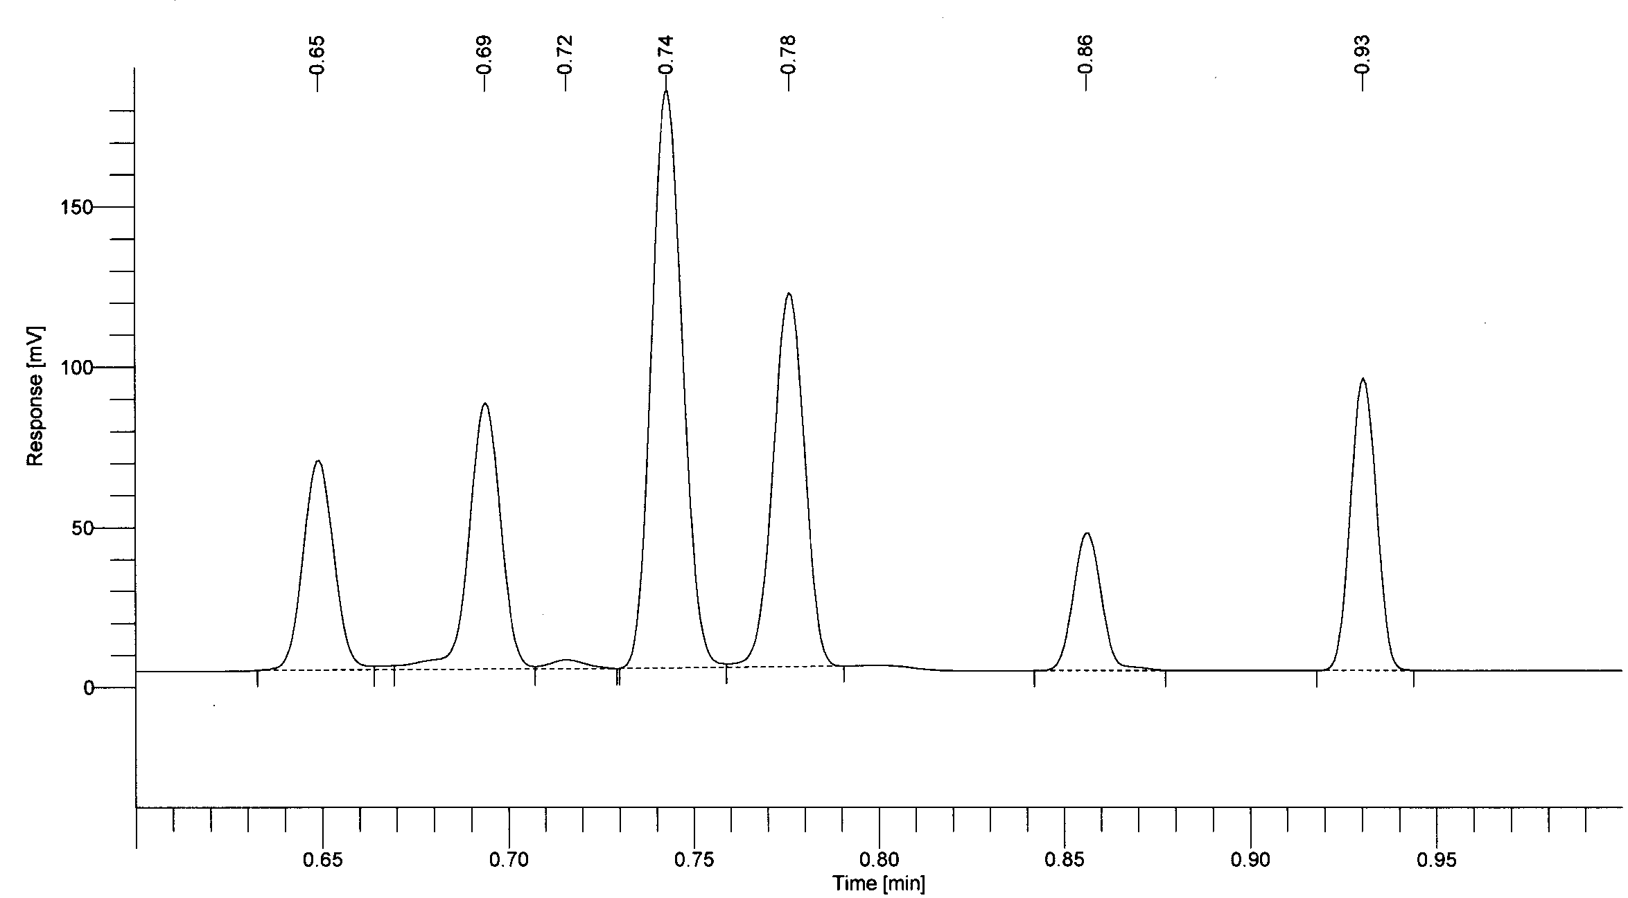

|  |  |
| --- | --- |
| **Retention Time (Minutes)** | **Compound** |
| 0.65 | Acetone |
| 0.69 | Methanol |
| 0.72 | Hexane |
| 0.74 | Cyclohexane |
| 0.78 | Heptane |
| 0.86 | Toluene |
| 0.93 | Ethylbenzene |

**GC Fractional Distillation Standard Data for GC #5**

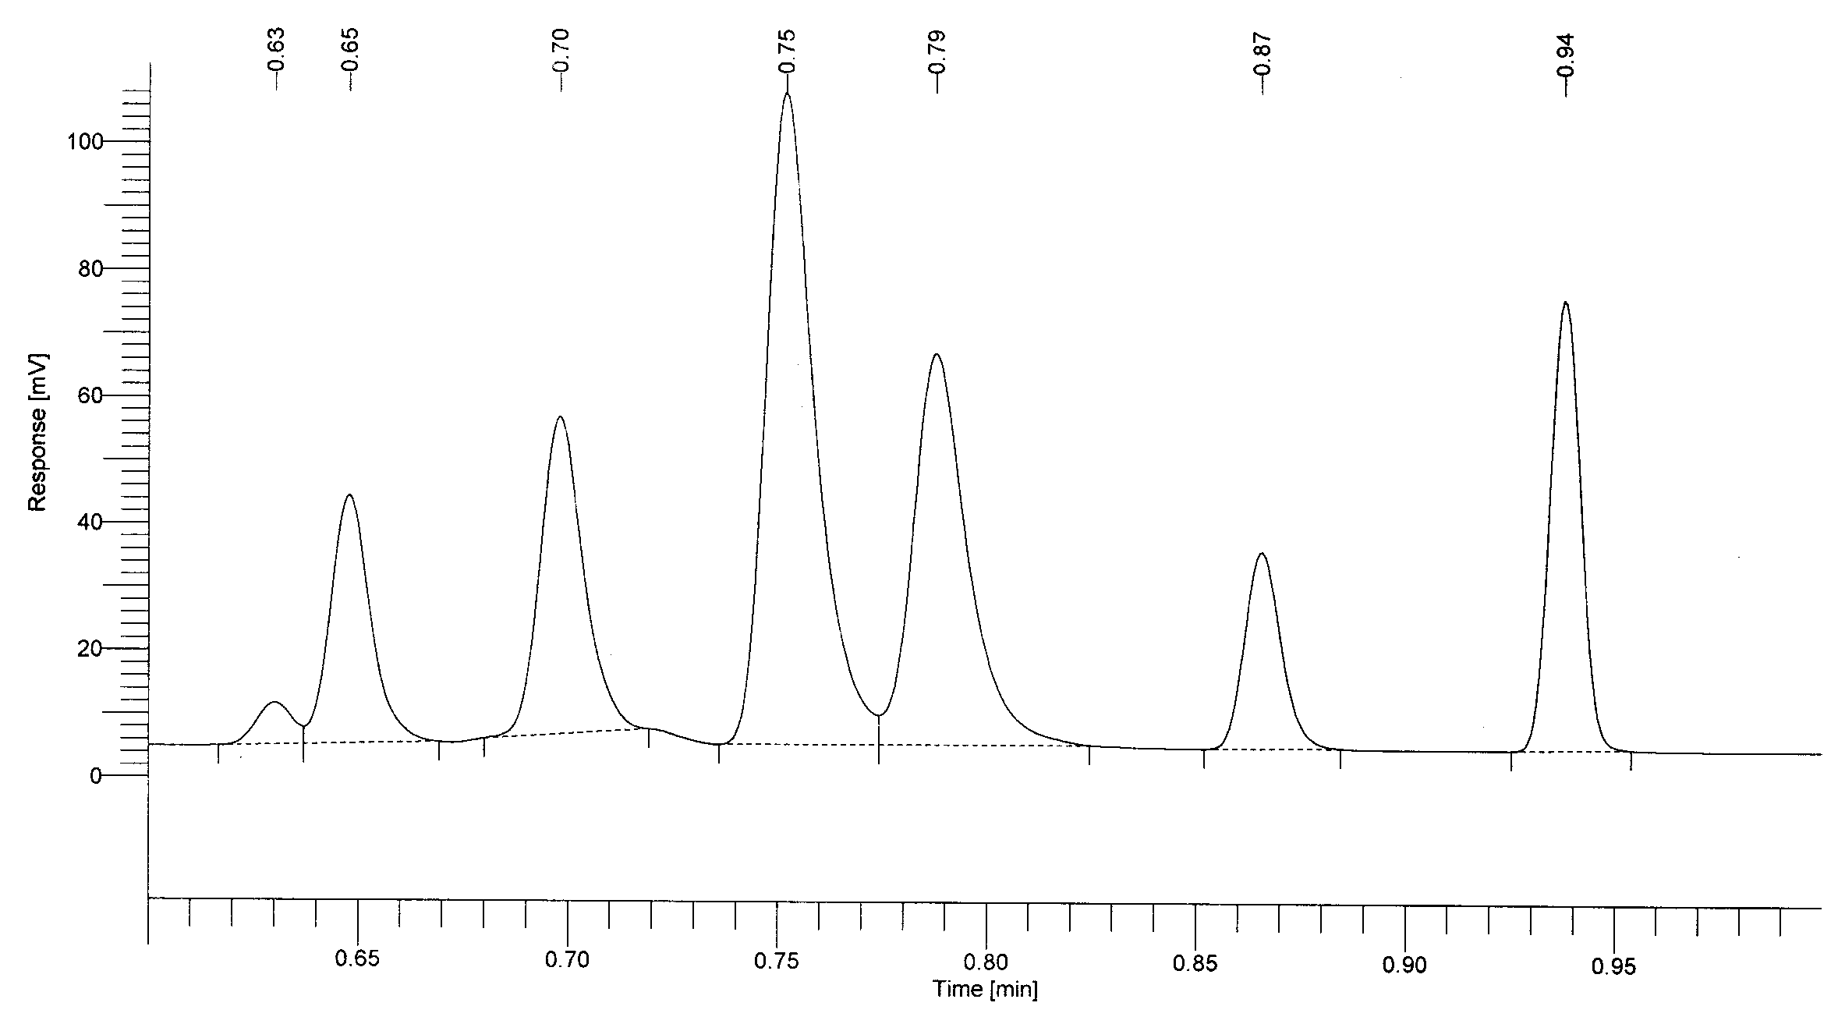

|  |  |
| --- | --- |
| **Retention Time (Minutes)** | **Compound** |
| 0.65 | Acetone |
| 0.69 | Methanol |
| 0.72 | Hexane |
| 0.74 | Cyclohexane |
| 0.78 | Heptane |
| 0.86 | Toluene |
| 0.93 | Ethylbenzene |