GC Number 1 (NHB 1.102)

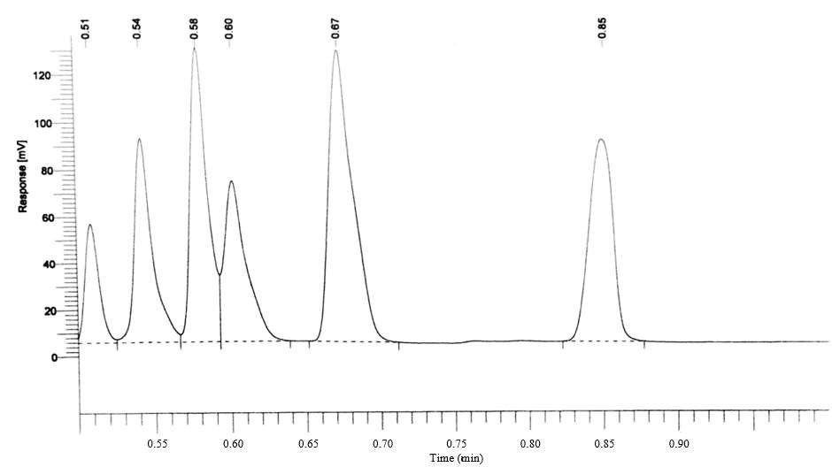

|  |  |  |
| --- | --- | --- |
| Peak | Solvent | Retention Time (min) |
| 1 | Acetone | 0.509 |
| 2 | Hexane | 0.542 |
| 3 | Cyclohexane | 0.579 |
| 4 | Heptane | 0.602 |
| 5 | Toluene | 0.671 |
| 6 | Ethyl Benzene | 0.847 |

GC Number 2 (NHB 1.116)

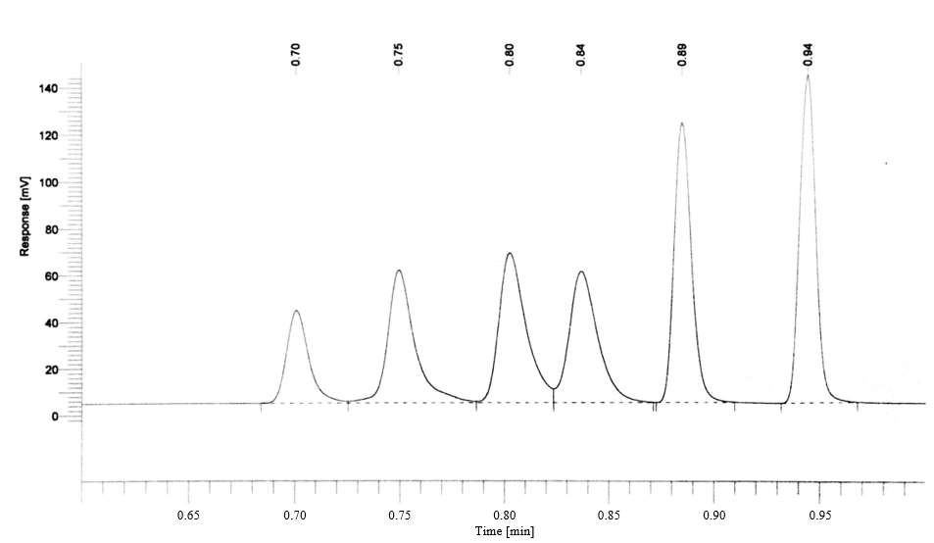

|  |  |  |
| --- | --- | --- |
| Peak | Solvent | Retention Time (min) |
| 1 | Acetone | 0.701 |
| 2 | Hexane | 0.750 |
| 3 | Cyclohexane | 0.803 |
| 4 | Heptane | 0.837 |
| 5 | Toluene | 0.885 |
| 6 | Ethyl Benzene | 0.945 |

GC Number 3 (NHB 1.126)

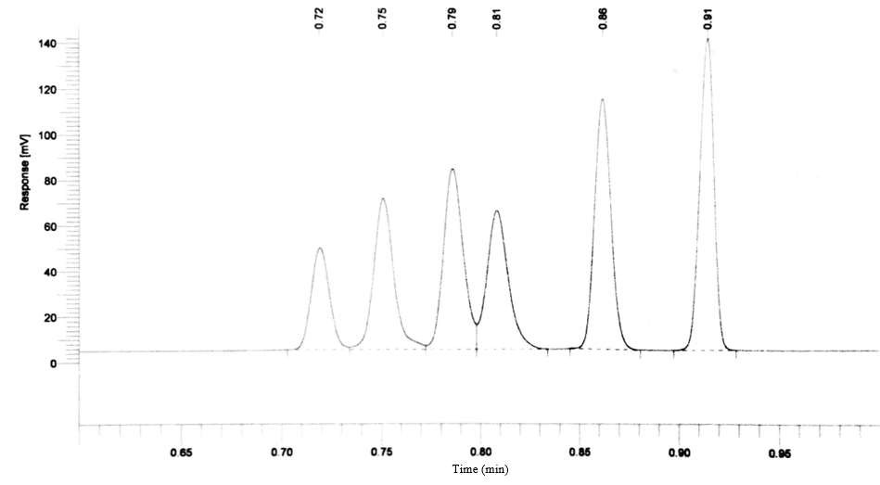

|  |  |  |
| --- | --- | --- |
| Peak | Solvent | Retention Time (min) |
| 1 | Acetone | 0.719 |
| 2 | Hexane | 0.751 |
| 3 | Cyclohexane | 0.786 |
| 4 | Heptane | 0.808 |
| 5 | Toluene | 0.862 |
| 6 | Ethyl Benzene | 0.914 |

GC Number 4 (NHB 1.124)

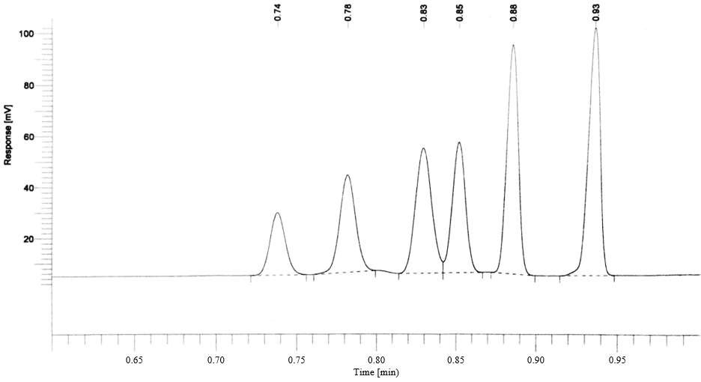

|  |  |  |
| --- | --- | --- |
| Peak | Solvent | Retention Time (min) |
| 1 | Acetone | 0.738 |
| 2 | Hexane | 0.782 |
| 3 | Cyclohexane | 0.829 |
| 4 | Heptane | 0.852 |
| 5 | Toluene | 0.885 |
| 6 | Ethyl Benzene | 0.935 |

GC Number 5 (NHB 1.118)

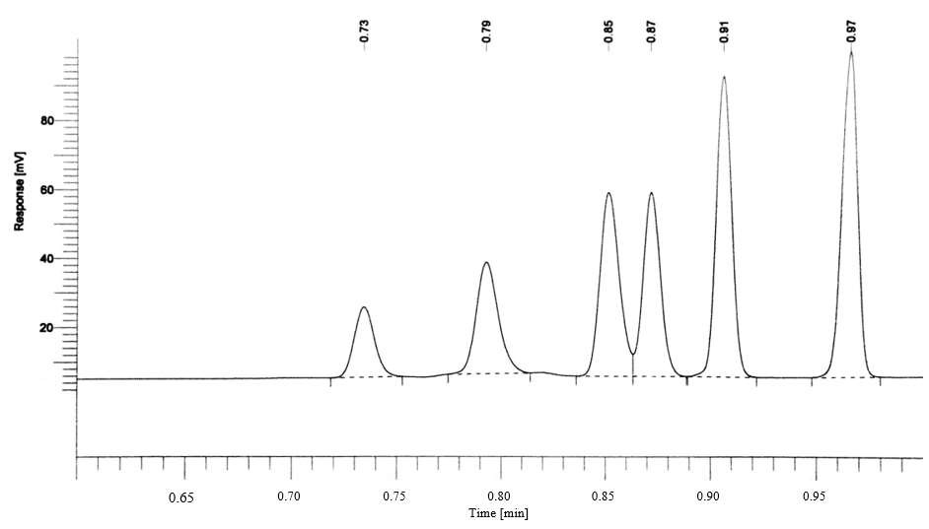

|  |  |  |
| --- | --- | --- |
| Peak | Solvent | Retention Time (min) |
| 1 | Acetone | 0.734 |
| 2 | Hexane | 0.793 |
| 3 | Cyclohexane | 0.852 |
| 4 | Heptane | 0.872 |
| 5 | Toluene | 0.907 |
| 6 | Ethyl Benzene | 0.965 |

GC Number 6 (NHB 1.110)

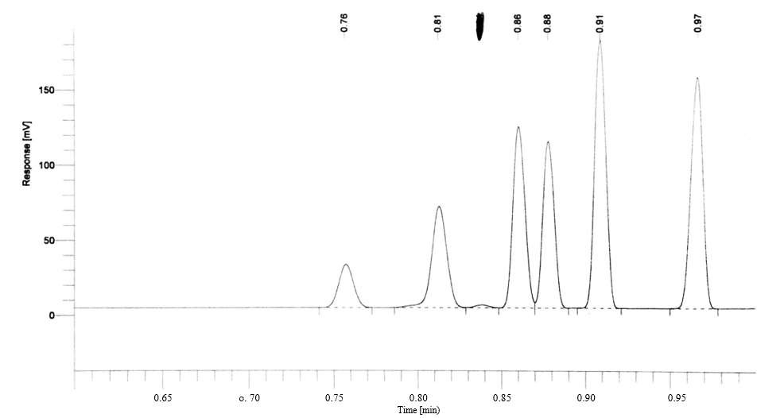

|  |  |  |
| --- | --- | --- |
| Peak | Solvent | Retention Time (min) |
| 1 | Acetone | 0.757 |
| 2 | Hexane | 0.813 |
| 3 | Cyclohexane | 0.861 |
| 4 | Heptane | 0.878 |
| 5 | Toluene | 0.909 |
| 6 | Ethyl Benzene | 0.966 |

GC Number 7 (NHB 1.106)

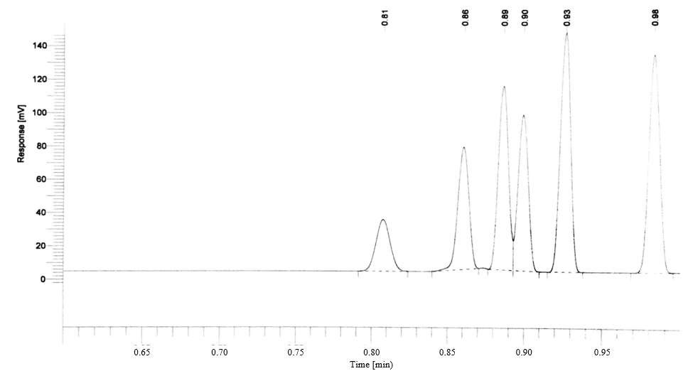

|  |  |  |
| --- | --- | --- |
| Peak | Solvent | Retention Time (min) |
| 1 | Acetone | 0.807 |
| 2 | Hexane | 0.861 |
| 3 | Cyclohexane | 0.886 |
| 4 | Heptane | 0.899 |
| 5 | Toluene | 0.927 |
| 6 | Ethyl Benzene | 0.983 |