Gas Chromatography Data

Fraction A
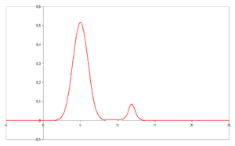
Peak 1 89 %
Peak 2 11 %

Volume 12 mL

Fraction B
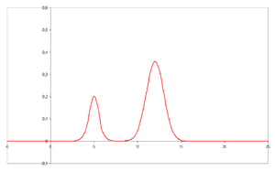
Peak 1 41 %
Peak 2 59 %

Volume 5 mL

Fraction C
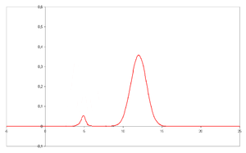
Peak 1 5.2 %
Peak 2 94.8 %

Volume 13 mL

Unknown Liquids

Lower cyclohexane
Higher toluene

