Mel-Temp Melting Point Apparatus
- The picture below shows a Mel-Temp melting point apparatus. This type of melting point apparatus uses long, thin melting-point capillaries. Note that you have to turn on both the heating block (green switch) and the thermometer (small switch on top) if your Mel-Temp has a digital thermometer. If your Mel-Temp has a traditional mercury thermometer, be careful not to break it!

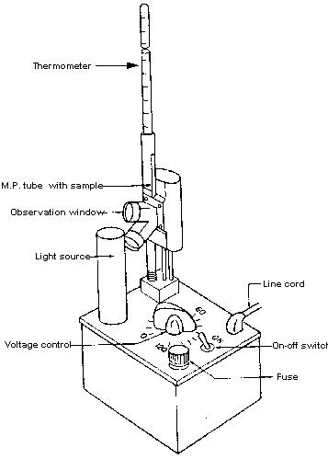

Technique for Taking a Melting Point
- Pack the capillary tube by pressing the open end gently into a sample of the compound to be analyzed.

- Crystals will stick in the open end of the tube.
- The solid should fill the tube to a depth of 2-3 mm. Drop the capillary tube down a length of glass tubing to pack the crystals into the bottom of the tube .

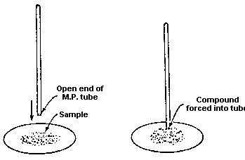

- When the crystals are packed into the bottom of the tube, place the tube into the slot behind the eyepiece on the Mel-Temp. Make sure the unit is plugged in and set to zero, then turn it on.
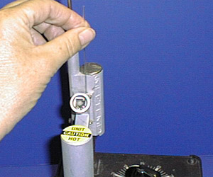
- Follow the directions given below to determine an appropriate heating rate. When finished, turn off both the unit and the thermometer and place the used melting point tube in the used melting point capillary tube receptacle.

- The rate of temperature increase in the vicinity of the melting point must be small, about 2 degrees C per min. This insures that the temperature of the hot plate, thermometer, and sample will be in thermal equilibrium. Increase the temperature rapidly at first and then slowly as the melting point is approached in the following manner:

- Set the power level to 5.
- When the temperature is about 15 degrees below the anticipated melting point, change the setting to that indicated on the graph below.
- Observe the crystals with your eye about 6" from the lens to prevent accidentally touching the hot apparatus. Record the temperatures at which melting begins and at which the last crystal disappears.

- If you do not know the melting point of a compound, first take a crude melting point by heating
