**Procedure for Column Chromatography**

**Column Setup**

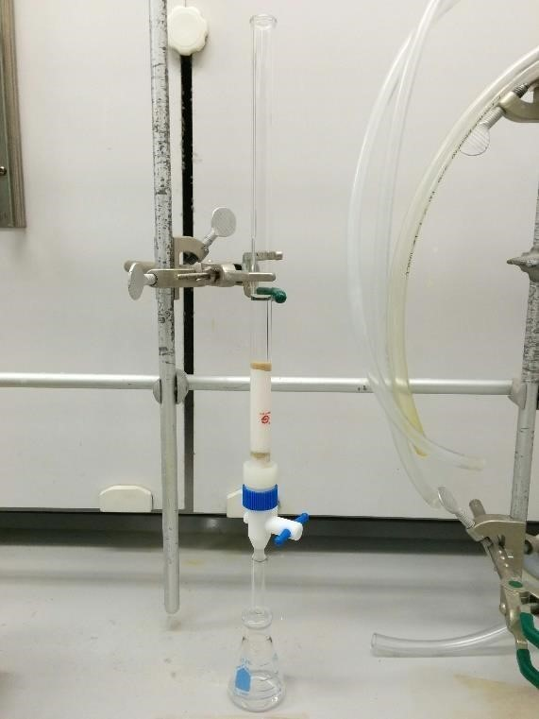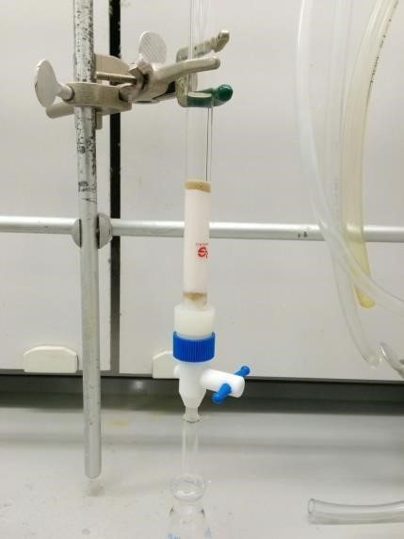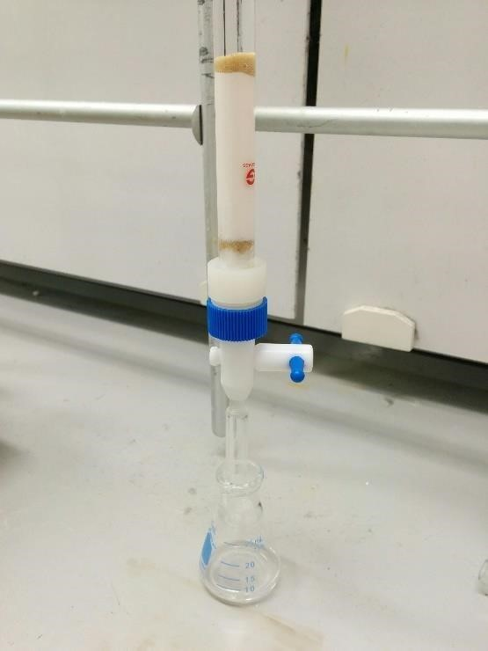

1. Use a metal clamp to hold the column.
2. Be sure the column is as close to vertical as possible.
3. Place an Erlenmeyer flask below the bottom tip of the column such that the tip is a few centimeters lower than the rim of the flask.
4. Double-check that the column does not leak. Close the stopcock and add a few mL of hexanes. Look to see if any drops drain out of the column. If some does leak, tighten the nut on the back of the stop cock and try again. If the leak persists, ask your TA about swapping out your column.

1. Remove the stopcock.  Roll a small piece of cotton into a ball and place it in the base of the stopcock (make sure it is not wound up tight).   Slowly add ~20 mL of hexanes to the column so as to not disturb the cotton.
2. Add sand to the column such that the height of the sand is ~1 cm.  If any sand is stuck to the side of the column, rinse with a small amount of hexane using a pipet.  Gently tap the column with your spatula a few times to help settle the sand and remove any air bubbles.
3. Repeat the process by adding 4 g of alumina with rinsing and tapping followed by another layer of sand ~ 1 cm with rinsing and tapping.

1. Once the second layer of sand is settled, open the stopcock and drain the hexane until the bottom of the meniscus is even with the sand.

# Procedure

1. Be sure that your column has been assembled properly.
2. Carefully add one mL of the 1:1 mixture provided to the column so as not to disturb the sand layer (try to keep the layer flat and even). Drain until the liquid is just at the level of the sand (i.e., the sand is still wet, but no liquid is above the sand).
3. Wash down the internal wall of the column with ~1 mL of hexanes. Again, drain until the liquid is just at the level of the sand.
4. Carefully fill the column with 20 mL of hexanes. Drain the liquid into an Erlenmeyer flask. Stop draining once the top of the liquid reaches the sand.
5. Add an additional ~5 mL of hexanes and drain into the same flask.
6. Carefully add 20 mL of dichloromethane to the column and then drain into a clean beaker. Watch as the yellow band moves down the column and drains into the beaker as a yellow liquid. Take the last drop or so of the yellow liquid for your TLC plate.
7. Once all of the yellow color has left the column, the separation is complete.
8. Pair up with partner and combine your fluorene fractions and your fluorenone fractions.
9. You then need to check the efficiency of the separation by running a TLC plate.
10. Get one of the pre-cut TLC plates. Using a pencil, draw a horizontal line across the narrow dimension about 2 cm from the end of the plate.
11. Draw two small tick marks, evenly spaced, on this horizontal line.
12. Take a glass spotter, provided in the lab, and dip into your first fraction. Touch the wet end of the glass spotter to the left tick mark of the TLC plate. Just one small spot will do.
13. Do the same for the second fraction but place your spot on the right tick mark. The TLC plate should have fraction 1 on the left and fraction 2 on the right.
14. Find your glass jar and add about ~1 cm of hexanes.
15. Carefully put the TLC plate in the jar with the tick marks at the bottom close to the liquid surface. Put the lid on the jar.
16. Watch as the liquid rises up the TLC plate. Once the liquid line gets close to the top, remove the TLC and use your pencil to mark where the liquid line is (do this relatively quickly because the line will disappear).
17. Look at the TLC plate under the UV lamp and use a pencil to circle the spots that you see. Use a ruler to determine the retention factor of the two compounds.
18. Take your Erlenmeyer flasks and air dry them to evaporate the solvents.  One person removes the solvent for the combined fluorene fractions and the other removes the solvent for the combined fluorenone fractions.
19. Weigh the solid products and observe their melting points.