**Procedure**

**Short story: Heat and stir a mixture of two solids and one solvent. Pour into water, cool, and filter the product.**

1. Put 300 mg meso-stilbene dibromide, 3 pellets KOH, 2 mL triethylene glycol, and a one-inch stir bar into a 25 mL Erlenmeyer flask.
2. Take out enough aluminum foil to cover your hot plate and make a hole wide enough for the mouth of the flask to go through, as shown in the picture below.

**\*\*\*YOU NEED TO MAKE THIS TENT FOR THE REACTION TO WORK AS DESIRED!!!**

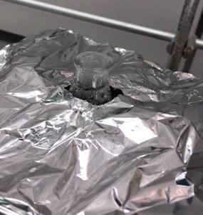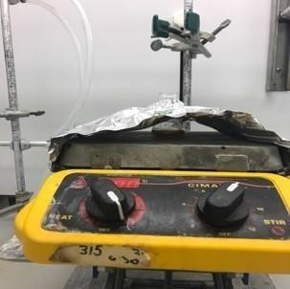

1. Center the flask so the stir bar stirs evenly at setting 5 or 6, then heat at 300˚C (NO preheating) for 5 minutes.

**BE SURE TO TIME THIS!!! ***After heating, the liquid should look like this:**

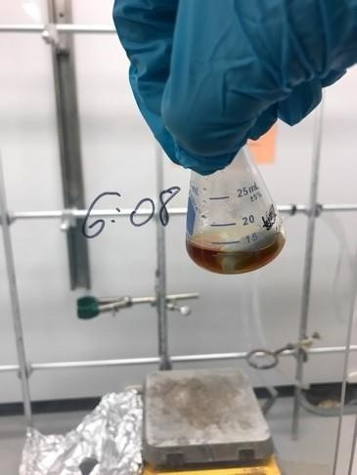

1. Fill the Erlenmeyer flask with ice and add room temperature DI water while swirling with your spatula to melt the ice.
2. Filter the product and rinse the crystals thoroughly with DI water.

**Recrystallization**

1. Scrape the crystals from the filter paper into a 30 mL beaker. Also, pour 50 mL DI water into a 150 mL beaker.
2. Dissolve your crystals starting with 1 mL ethanol, adding 0.5 mL at a time until the solid is dissolved.
3. Set the heat to 150 ˚C and heat both the 30-mL and 150-mL beaker!
4. Once the crystals dissolve, add several drops of hot DI water into the beaker containing your product until you see a small white precipitate that lasts for more than one second.
5. Add several drops of ethanol into the beaker containing the product until the small precipitate disappears.
6. Remove the 30 mL beaker from the hot plate and cool it slowly by placing it in your hood for 5 minutes. Then, cool it in an ice bath for 10 minutes until you see crystals.
7. Scrape the crystals, rinse with DI water, and filter using vacuum filtration. Rinse crystals with DI water while filtering.

**Hazard Analysis for Dehydrobromination**



|  |  |
| --- | --- |
| **Hazard** | **Scenario** |
| **1.**Hotplate | Setting notebook on hotplate after just turning it off. |
| **2.**Potassium Hydroxide | Accidental exposure to eyes. |
| **3.**Triethylene glycol | Accidental ingestion. |
| **4.**Loud Music | Fire Alarm |



**Data Analysis Questions for Dehydrobromination**



**A.**Melting Point

**1.**What does the melting point data tell you?

**2.**Were there any errors?

**3.**What caused them?

**4.**Why do these errors result in the data you received?

**B.**Percent Yield

**1.**What was your percent yield?

**2.**Is this good or bad?

**3.**Why?

**4.**Were there any errors observed?

**5.**What caused these errors?

**6.**Why do the errors give you the results in the experiment?

