**Distillation**

**Apparatus Setup**

**The equipment setup for this lab will require the use of the following glassware assembled as shown:**

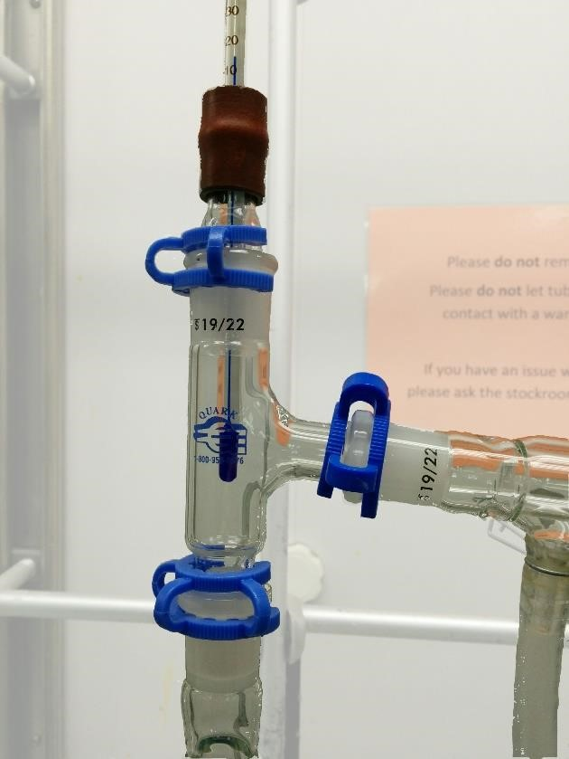

|  |  |
| --- | --- |
|  | 1. Place the 3-way adapter over the correct indentation of the aluminum heating block (**the largest indentation**) and secure it to the scaffolding with a clamp. Be sure that the largest indentation is centered on the hotplate. 2. Get the straight adapter and put the rubber adapter over the rounded end. Gently slide the thermometer into the rubber adapter. 3. Place the straight adapter in the top of the 3-way adapter and add a Keck clamp. 4. Be sure to grease each joint properly. |
| 1. Adjust the thermometer such that the bottom of the thermometer is line with the bottom of the arm of the 3-way adapter. |  |

**The horizontal portion of the apparatus should be assembled as such:**

|  |  |
| --- | --- |
|  | 1. Attach this condenser to the arm of the 3-way adapter and add a Keck clamp. 2. Attach water hoses to condenser with hose clamps. Clamp this condenser securely using a metal clamp. 3. Connect the vacuum adapter to the end of the condenser and add a Keck clamp. 4. Position and clamp the first 15 mL centrifuge tube (**labeled fraction A**) below the vacuum adapter such that liquid flowing out of the adapter will flow into the falcon tube. |
|  |  |
| 1. Acquire 30 mL of the solution in a graduated cylinder and pour into a 100 mL round-bottom flask with 1 inch stirbar. 2. Attach to bottom of 3-way adapter and add a Keck clamp. 3. Raise the hot plate by turning the knob on the riser until the round-bottom flask rests snuggly in the aluminum block. 4. Then loosely wrap the apparatus with aluminum foil. |  |

**Distillation Procedure**

Your sample will contain an unknown ratio of acetone and toluene.

**Prior to performing the distillation, prepare a graph in your notebook for plotting the head temperature *vs.* the *cumulative* volume of distillate obtained. During the distillation, look for plateaus, collect three fractions, A, B and C, and record their respective volumes. Measure the amount of residual liquid in the distillation flask (if any) so that a % composition of distilled liquid can be calculated. Also record the boiling points of A and C.**

1. Begin by heating the round-bottom flask. Turn on the magnetic stirring to 3-4 and turn the hotplate temperature to the temperature as directed from your TA (usually about 250 ºC).
2. Once the first drop of distillate drops into the centrifuge tube, start recording the temperature. As each additional mL of solution comes over into the centrifuge tube, check the thermometer and record the temperature. Eventually, the temperature will level off. This is the boiling point of the lower boiling compound in the mixture. There are 2 conditions that, if either is met, necessitate swapping fraction A for a new centrifuge tube:
   1. The liquid is close to overflowing the centrifuge tube (or exceeds the graduated portion of the tube)
   2. The temperature deviates from the plateau by more than 3 degrees C (higher or lower)
3. Once one of the conditions is met, swap fraction A for a new centrifuge tube, cap fraction A, and place the centrifuge tube in a beaker so that it stays upright.
4. Once fraction A has been replaced with an empty centrifuge tube, be ready to adjust the temperature depending upon how it changes (increase or decrease). Continue collecting and recording the temperature as each mL of liquid comes over.
5. Eventually, the temperature will plateau again. Once the plateau has been identified (2-3 mL of liquid comes over at the same temperature), swap out fraction B for a new centrifuge tube, cap fraction B, and place it upright in the beaker with fraction A.
6. Continue collecting liquid until the rate of drops is very slow. Check the round-bottom flask periodically to ensure that there is still liquid in the flask. Do not distill to dryness, as peroxides may form, concentrate, and detonate.
7. Once most of the liquid has been distilled (there will probably be about 0.5 mL remaining in the round bottom flask). Cap fraction C and place with the other fractions. Turn off and lower the hotplate to allow the roundbottom flask to cool. Turn off the water in the condenser.
8. Tell your TA that you have finished collecting the fractions and are ready to perform the GC analysis. Obtain GC plots for each of your fractions and carefully disassemble the distillation apparatus.