Extraction Procedure
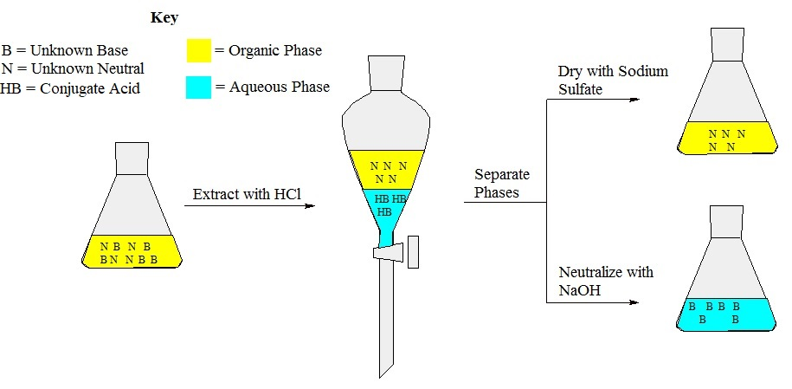

Work in groups of two. Each person in the group will perform the extraction.

Place ~10 mL of the NaOH solution in an Erlenmeyer flask and place it on ice (only one per group).

Weigh out 0.25 g of the unknown and dissolve in 10 mL of ethyl acetate.

Place the separatory funnel in a ring stand, close the stopcock, and add a small portion of water to make sure the separatory funnel doesn't leak. Tighten the nut if it does. Drain the water.

Add your ethyl acetate solution to the separatory funnel and then add 10 mL of the HCl solution.

Put the glass stopper on top of the separatory funnel, remove the funnel from the ring stand, and carefully shake the funnel while firmly holding the glass stopper on with one finger.

Stop shaking, invert the funnel, and slowly open the stopcock to vent the separatory funnel. You may hear a small hissing sound as gas escapes.

Close the stopcock, place the funnel upright back in the ring stand and remove the glass stopper.

Drain the aqueous (bottom) layer into a clean Erlenmeyer flask (this is your acidic extract). The ethyl acetate (top) layer should remain in the separatory funnel.

With your partner, combine your ethyl acetate solutions together and combine your HCl solutions together. One person in the group will isolate the unknown base compound and the other will isolate the unknown neutral compound.

Isolating the unknown base

Place the Erlenmeyer with the acidic extract into an ice bath for ten minutes beside the sodium hydroxide.

While still in the ice bath, neutralize the acidic extract (the first extract) with the cold ~10 mL of the NaOH solution. Check the pH with pH paper to ensure that it has been neutralized. The unknown base should have precipitated out of solution. Note if no or very little precipitate appears: A thin layer of ethyl acetate is often on top of the aqueous solution. Blow air across the top of the aqueous solution until precipitate appears.

To isolate your unknown base, filter the solution with your Buchner funnel and scrape the solids onto a labeled weigh boat. Store it in your locker until next week.

Isolating the unknown neutral

Drain the remaining ethyl acetate solution into a small Erlenmeyer flask. Add approximately 4 spatulas worth of sodium sulfate.

Remove the sodium sulfate by pouring your ethyl acetate solution through your glass funnel with a small piece of cotton at the base letting it drain into a clean beaker. Next, do one of the following:

If you are in 128K/120K then blow air over the solution to evaporate the solvent. You should be left with the neutral organic compound as a solid in the beaker.

Recrystallization Procedure

Note: Make sure you weigh and obtain a melting point of each of the crude samples before you recrystallize them.

- Remove the aluminum block from the hotplate, and turn the hotplate on to 250 ºC
- Add roughly 75 mL of water to your largest beaker and place it on the hotplate.
- Add roughly 20 mL of methanol to your second largest beaker and place it on the hotplate.
- Add your crude base and neutral compounds to seperate, smaller beakers. Preferably, place the neutral compound in the smallest of the three beakers and place the base in the biggest of the three beakers.
- Obtain two plastic pipettes.
- The methanol will begin to boil first. If the boiling is very vigorous turn the hotplate down or move the beaker to the edge of the hotplate where it is cooler.
- Add a pipette of hot methanol to the beaker containing the neutral compound. Keep adding hot methanol until there is enough liquid to cover the bottom of the beaker.
- Place the beaker containing the neutral product onto the hotplate to reheat the solvent.
- If the solvent begins to boil but there is still solid floating around, add another pipette of hot methanol.
- Once all of the solid dissolves, remove the beaker containing the neutral compound off of the hot plate and cover with a watch glass to prevent the solvent from evaporating.
- Remove the beaker containing pure methanol from the hotplate. This is now waste.
- Repeat this procedure with the base, but use boiling water as the solvent. Once you remove these solutions from the hotplate, you do not need to cover them with a watch glass, since the water does not evaporate quickly. Don't forget to turn off the hotplate after you have finished dissolving all three compounds.
- Once the solution containing the neutral has cooled to room temperature, you should see some precipitate form. Put the beaker into an ice-water bath while you set up you Buchner funnel.
- After a minute or two in the ice-water bath, pour the neutral compound into the Buchner funnel and vacuum filter. Wash the crystals with ~5 mL of cold methanol. Then move the crystals to labeled weigh boat.
- Repeat this process for the base compound. Wash these compounds with cold water instead of methanol.
- Once you have your two crystalline products, you can clean up your glassware and let your compounds air dry until the next week.
- The following lab period, you need to obtain the mass and melting point of each of your two compounds using a Mel-Temp apparatus.
List of Unknowns

Type | Unknown | MP (°C)
 | 4-nitroaniline | 149–151
Basic | 2-methyl-4-nitroaniline | 131–133
 | 3-nitroaniline | 112–114
 | 9-fluorenone | 82–85
Neutral | anthracene | 216–218
 | fluorene | 114–116
 | phenanthrene | 101–103

