**Reduction of 9-fluorenone**

1. Measure out 3 mL from the bottle labeled “0.185M 9-Fluorenone in Methanol” and add it to a 25 mL round bottom flask with a 1-inch stir bar.
2. Using a clean pipette, add 7 drops of 4.4M Sodium borohydride to the 25mL round bottom flask and note the color change. If there is no color, add 2 more drops of the sodium borohydride solution.
3. Using the supplied syringe, add 0.45 mL of 3M sulfuric acid carefully. The first few drops lead to intense bubbling and so it is best to add the acid slowly in a dropwise fashion until the bubbling settles down. Keep adding the acid slowly allowing the bubbles to dissipate.

* **The first few drops leads to intense bubbling and so it is best to add the acid slowly in a dropwise fashion until the bubbling settles down. Then, add the rest of the acid.  
  Make sure the syringe is empty and wiped clean before placing back in the basket.**

1. Add 3 mL methanol into the flask then heat under reflux for 10-12 minutes. Start heating at 300˚C, then once the vapor line on the condenser reaches 1/3 of the way, lower heat to 150˚C and continue heating.

**Reflux is finished when the liquid is clear or close to it.**

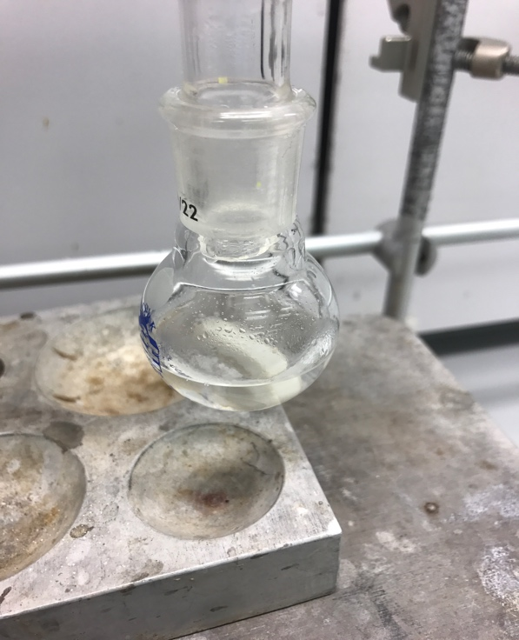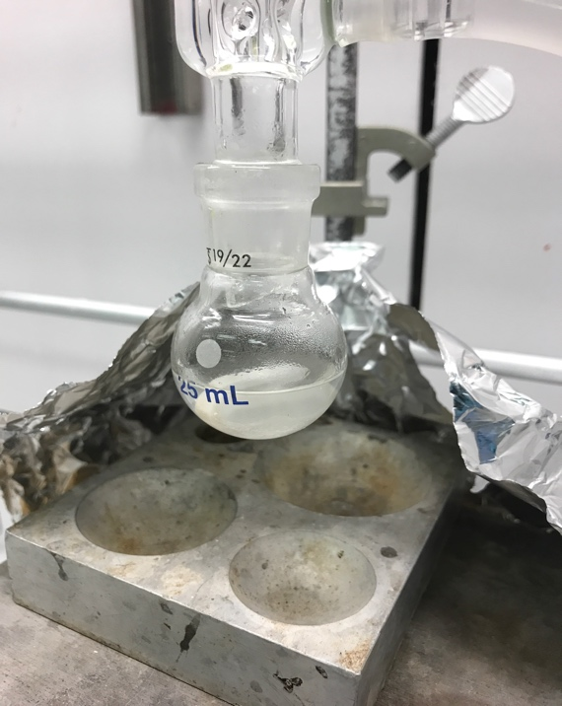 **NOT READY READY**

1. Remove round bottom flask from hot plate and fill with ice chips and DI water. Let it cool for 5 minutes.
2. Vacuum filter the product using 2 filter papers and DI water. Pay attention to the receiving flask, as the product can leak out. If it does, pause filtration, transfer the filtered liquid onto a beaker, and filter again.
3. Rinse the product thoroughly with DI water to neutralize the product. First, turn off the vacuum knob at the side of the hood then fill the Büchner funnel with DI water. Let the water leak out of the Büchner funnel, and repeat at least 3 times. Check pH by touching pH paper at the bottom tip of the Büchner funnel.

**Again, if the product leaks into the receiving flask, you have to filter that liquid again**.

1. Transfer the filtered solid product onto a 30 ml beaker, and fill a 150 ml beaker with DI water to the 50 ml mark. Also, fill any container of your choice with 5 ml methanol.
2. Add 1.5 ml methanol to the product and heat both the 30 ml and 150 ml beakers at 150˚C. Occasionally swirl the product while heating to aid dissolution. If the product does not dissolve, add methanol in 0.5 ml increments.
3. Once dissolved, add drops of hot DI water from the other beaker using a pipette. Keep adding drops of water until you see a white precipitate that stays for about 1-2 seconds. **Then, carefully add 1-2 drops of methanol.**

**Be very careful with pipetting the hot water and the 1-2 drops of methanol. These liquids can leak out, so it is best to wet the pipette first with the liquid you are about to use to induce surface tension.**

1. To cool the crystals, first submerge the 30 ml beaker under regular water for 5 minutes then transfer to an ice water bath. In total, you should cool for at least 10 minutes.
2. Vacuum filter product and rinse with one mL of DI water.
3. Let product dry and then take a melting point, take an IR and determine the percent yield.