The equipment setup for this lab will require the use of the following glassware assembled as shown:
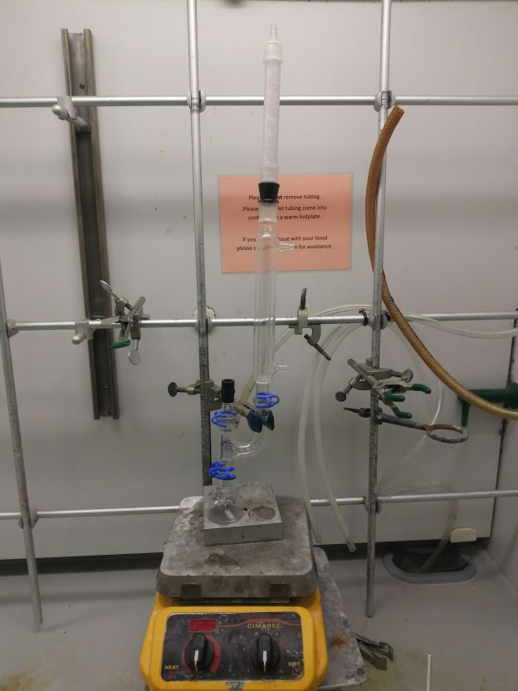 | - Do not forget to lightly grease all ground glass joints while setting up the distillation apparatus or the glassware may seize together. Place a very small amount of grease on the male joint and then connect the glassware together and rotate them until the grease is spread evenly before securing it with a Keck clamp.  - Place the drying tube at the top of the condenser but do not attach the water lines.
- There are multiple indentions on the heating block, make sure that they use the one that fits the round bottom properly.  - Attach the straight adapter and thermometer adapter on the straight side of the Claisen adapter. | 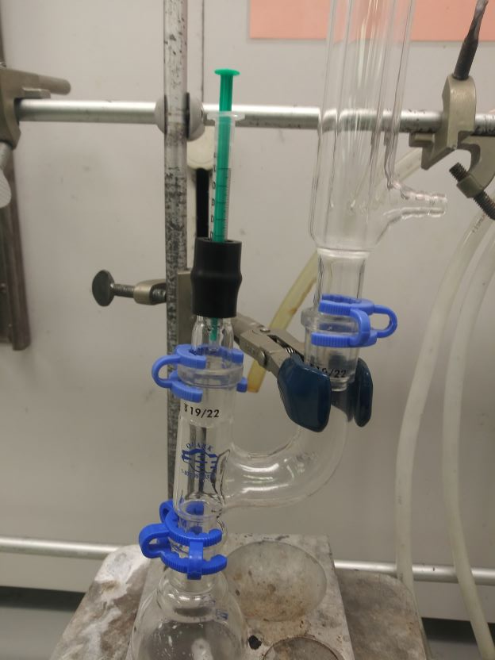

Grignard Procedure
General steps students should follow:
- Very lightly grease the joints between the Claisen adapter and the condenser (which should be attached to the curved side of the Claisen adapter). Do not hook up the water lines. Attach your straight adapter with thermometer adapter to the Claisen adapter. Lightly grease the male joint of the Claisen adapter and have it ready to connect to the round bottom flask.
- Add 0.5 g of Mg powder to a clean and dry 50 mL round-bottom flask and a one inch stir bar.
- Prepare a solution of 5 mL ether and approximately 2.5 mL of bromobenzene. Add 4 mL of this solution to the 50 mL round bottom flask.
- Add 5 mL of ether to the round-bottom flask.
- Using a nylon rod, start grinding the magnesium power to the bottom of the flask until the solution turns cloudy. Quickly connect the round bottom flask to the Claisen adapter.
- Add the rest of the bromobenzene solution dropwise through thermometer adapter using a syringe. It should take about 15 minutes to add it all. Let the reaction continue to mix for an additional 15 minutes or until the solution has turned a dark brown color.
- Crush 5 or 6 pieces of dry ice and add ~ 10 g of the pieces to a 125 mL Erlenmeyer flask (crush using the aluminum heating block).
- Pour the reaction mixture into the large beaker that contains the dry ice and swirl to mix thoroughly. Rinse the round bottom flask with 5 mL of diethyl ether and add it to the flask. Swirl the mixture in the flask for 5 minutes, and then set it down and let the excess dry ice sublime.
- While the dry ice is subliming, prepare a solution of 5 mL of sulfuric acid in ~5 mL of water. Add the sulfuric acid slowly to the water, and then place on ice until it is needed.
- Add the sulfuric acid solution to the reaction mixture slowly, there will be some bubbling as the excess magnesium dissolves. The ether volume should be about 25 mL. If below 25 mL, add more ether until it reaches 25 mL
- Transfer the solution to the separatory funnel, you should be able to observe two clear layers (the top is ether the bottom is aqueous)
- Shake the separatory funnel (and vent) then drain the bottom aqueous layer (waste).
- Add 10 mL of sodium hydroxide solution, shake, vent, and drain the bottom aqueous layer (product!) Into a clean beaker
- Acidify the basic solution with 6 M HCl until the pH is ~1, white precipitate will form.
- Cool the beaker in an ice-water bath while you set up the Buchner funnel.
- Filter the solid product and wash with cold water.
- Save the product for the following week for product analysis.
  - For 220C, obtain a % yield, IR, and MP.
  - For 128L, obtain a % yield, IR, MW titration, and MP.

Molecular Weight Determination by Titration
(128L Only)

- Place 0.2 g of the benzoic acid into an Erlenmeyer flask that contains 25 mL of methanol and your one inch stir bar.
- Once the solid has dissolved, add a drop or two of phenolphthalein solution.
- Using a Burette, titrate the solution with 0.1 M NaOH until the pink endpoint.
Note: Do not use more than 25 mL of the 0.1 M NaOH solution.
- Note the volume of the NaOH necessary to titrate the benzoic acid and then calculate the molecular weight of the benzoic acid.

