Hydration of Norbornene

The equipment setup for this lab will require the use of the following glassware assembled as shown:

Separatory funnel  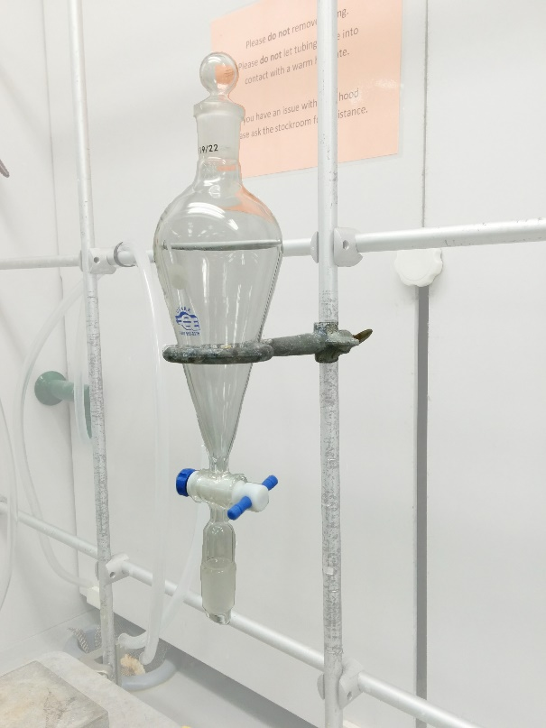 | Erlenmeyer flask  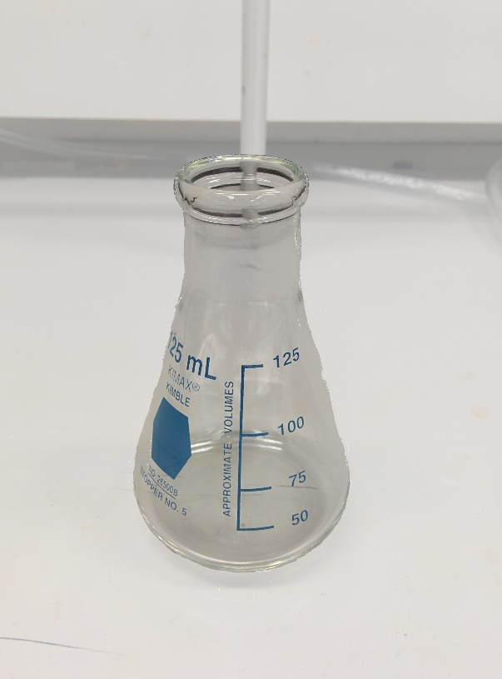
Petri dish without lid  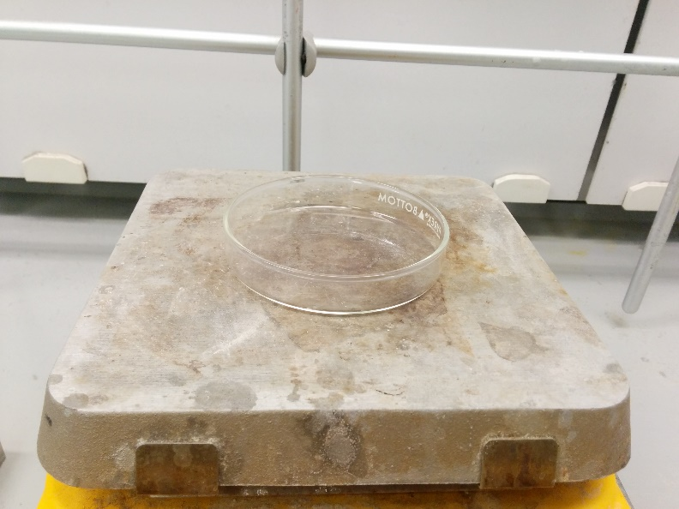 | Petri dish with lid  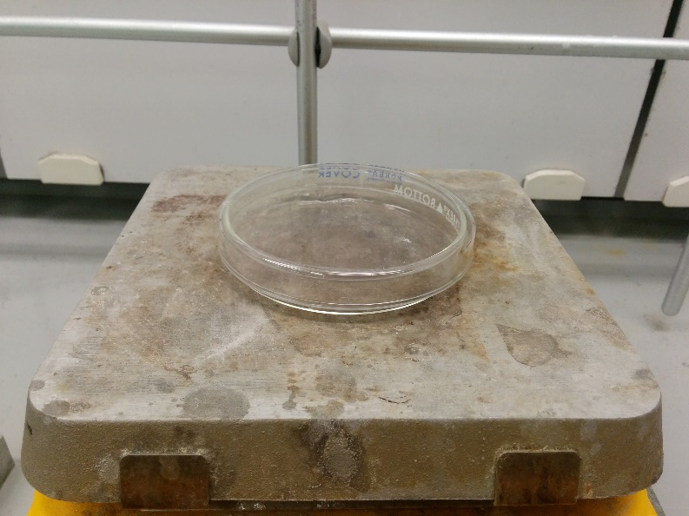

Procedure
- Pour 1 mL of water into an Erlenmeyer flask with a stir bar.
- Slowly add 2 mL of concentrated sulfuric acid while continuing to stir.
- Add 1 g of norbornene portionwise and stir until it dissolves (if it does not dissolve after 10 minutes, continue with the rest of the procedure). If the flask gets warm, dunk the Erlenmeyer in an ice-water bath briefly.
- Once the solid has dissolved, cool the solution in the ice-water bath.
- Slowly add the KOH solution provided to neutralize the solution. Be sure the solution is room temperature or colder before proceeding.
- Pour the solution into the separatory funnel and add 15 mL of diethyl ether and mix. If an emulsion appears, pour contents of flask into large beaker. Rinse the flask with 15 mL of water and add to beaker. Add water until the total is about 100 mL. Use a spatula to break up emulsion and then add to the separatory funnel.
- Put the glass stopper on the separatory funnel, and while holding the stopper one with a finger or two, carefully invert the separatory funnel and vent immediately.
- Close the stopcock and vigorously shake the separatory funnel about 20 seconds or so then vent once again.
- Place the separatory funnel back into the ring stand, remove the glass stopper, and drain the bottom (aqueous) layer into an Erlenmeyer flask.
- Drain the organic layer onto a clean Erlenmeyer flask.
- Add the aqueous layer back into the separatory funnel and add 10 mL of fresh diethyl ether.
- Put the glass stopper on the separatory funnel and shake for another 20 seconds or so.
- Place the separatory funnel back into the ring stand, remove the glass stopper, and drain the bottom (aqueous) layer into an Erlenmeyer flask.
- Pour the ether extract that was set aside earlier in the separatory funnel with the new batch of diethyl ether (i.e., combine the organic extracts).
- Perform 3 washes. The first with 5 mL of distilled water, the second with 5 mL sodium bicarbonate solution, and the third with 5 mL of sodium chloride solution. All the bottom (aqueous) layers can be drained into the same Erlenmeyer as they will be waste.
- Drain the organic layer into a clean Erlenmeyer flask, add about 4 spatulas of anhydrous sodium sulfate, and swirl the flask for about 15 seconds.
- Carefully filter your ether (using your glass funnel with a small piece of cotton at the base to remove the sodium sulfate) or decant it directly into a glass petri dish. Gently air-dry the ether using the air hose to evaporate the ether. Once most of the ether is removed and you start to see the solid form, add a piece of filter paper to the dish to remove excess water and place the lid on top of the petri dish. Wrap parafilm around the petri dish to prevent any product loss. Store the sealed petri dish in your drawer for the following week for sublimation.
Sublimation:

- Unwrap the parafilm and remove the filter paper from your petri dish. Place the petri dish on your hot plate.
- Gently warm the hot plate (temp reading about 120 °C) and observe crystals forming on the upper lid of the petry dish. Once most of the material has sublimed, remove the petry dish from the heat and scrape the material from the top lid into a prewighed weigh boat.
- Get the mass, melting point, and the IR spectrum.

