The equipment setup for this lab will require the use of the following glassware assembled as shown:

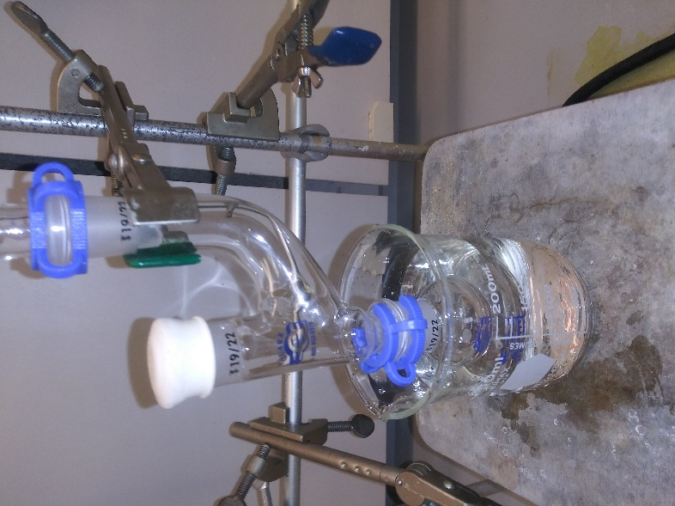  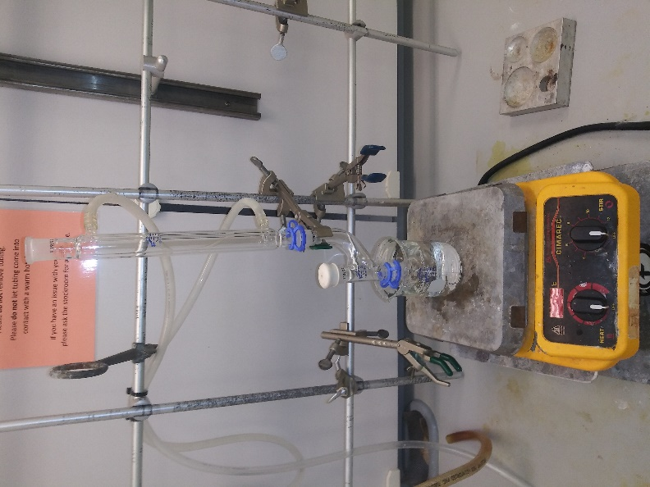 | - Use your 25 mL round bottom flask and add your rice stir bar. Attach the Claisen adapter to the flask making sure to lightly grease the joint between the Claisen adapter and the flask. Also be sure to attach a Keck clamp. Place the rubber septa on the straight arm of the adapter (do not grease and be sure to return the rubber septa at the end of lab). Attach the condenser to the curved arm of the adapter (again be sure to grease the joint and add a Keck clamp).  - Place a 250 mL beaker filled with 150 mL of water in the center of the hotplate. Raise the hotplate so that the 25 mL round bottom flask is submerged halfway into the water. (Do not turn the hotplate on).  - Attach the water hoses to the condenser with metal hose clamps and turn the water on so that it is running very slowly. The water inlet hose is placed on the bottom of the column and the outlet hose is placed on the top.

Procedure
- Set up the hydroboration apparatus. Be sure to attach the water hoses with hose clamps and turn the water on so that it is running very slowly. The water inlet hose is placed on the bottom of the column and the outlet hose is placed on the top.
- In the small graduated cylinder, prepare a solution of 1.6 mL alpha-pinene in 2 mL of THF.
- (The following step is done by the TA) Add 5 mL of 1 M solution of borane-THF complex in THF into the round-bottom flask through the rubber septum using a syringe.
- Apply a room temperature water bath to the round-bottom flask and stir the solution.
- Using a syringe add the α-pinene solution to the round-bottom flask slowly over the course of a few minutes. Once the addition is complete, allow the reaction to stir for 60 minutes.
- Replace the water bath with an ice-water bath and let the flask cool for 3-5 minutes.
- Remove the rubber septum and slowly add 0.5 mL of water to the round-bottom flask.
- Prepare a solution of 1.5 mL of 30% aqueous hydrogen peroxide and 1.5 mL of 3 M aqueous sodium hydroxide.
- Slowly add this solution to the round-bottom flask (bubbling will most likely occur). Stir for 10 minutes after the addition is complete.
- Pour the reaction mixture into the separatory funnel, rinse the round-bottom flask with 5 mL of water, and pour the water into the separatory funnel.
- Add 10 mL of ether to the funnel. After extracting for 5 minutes, drain the bottom layer (aqueous) into a beaker and set aside. Then drain the top layer (ether) into a separate flask. Pour the aqueous layer back into the separatory funnel. Add a second 10 mL of ether to the funnel and extract a second time. Drain both layers into separate beakers. Combine both ether layers and put back into the separatory funnel.
- Wash the combined organic layers first with 10 mL water, then perform a second wash with 10 mL of saturated sodium chloride solution. (A wash is a liquid-liquid extraction where you are removing unwanted material from the original solvent. Drain the bottom aqueous layer after each wash).
- Pour the ether into a beaker and dry the ether with 3-4 spatulas of anhydrous sodium sulfate.
- Filter the ether with your glass funnel and a piece of cotton to remove the sodium sulfate. Collect the ether into a large beaker and air dry it with the air hose.
- Weigh the product for a percent yield, obtain the melting point, and an IR spectrum.

