**Synthesis of Luminol**

1. Place 0.200 g nitropthalic acid, 0.4 mL hydrazine, and 2 mL triethylene glycol in a conical vial and stir with a rice stirbar.
2. Center the aluminum heating block on the hotplate and place the conical vial in the appropriate hole in the aluminum block and stir at 5.
3. Set heat to 300˚C and attach a heat tent as shown below. **Heat at this temperature ~45 minutes or until the color of the solution turns dark brown, as shown below.**

*Cut a piece of aluminum foil, enough to cover the area of the hotplate, and then puncture a hole at the center for the vial to pass through. Then, wrap the foil around the sides of the hotplate, making sure that there is air underneath the tent. \*\*\**

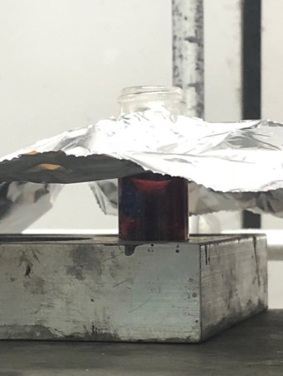

1. Remove heat tent carefully and, using your test tube holder, slowly remove the conical vial from the hotplate.

*** When using the test tube holder, pinch the handle to wrap it around the vial and let go! Once it is around the vial, it will be secure. **If you continue pinching it, it might loosen and you will lose your product! Also, if the holder is not fastening, ask the TA to fix it.** ***

1. Let the vial cool inside your hood and begin heating 20 mL of DI water in a beaker. Once it is boiling, remove it from the hotplate and ***slowly******pipette******dropwise* 3 mL** of hot DI water onto the conical vial**. Pause addition when you see bubbling, and resume once the bubbling subsides.** Also, turn off the heating for the hotplate.
2. Place conical vial in an ice water bath for 10 minutes or until you see a yellowish brown solid. **Make sure the solution is fully submerged in the ice bath!**
3. Transfer the solid in a clean centrifuge tube, and note the volume of the solution. Then, in another centrifuge tube, add DI water so that it has the same volume as the other tube. This is called *counterbalancing*! **Make sure the cap is compatible with the tube and it fully tightens!**
4. Locate the centrifuge in the lab, and plug it in. Once the LED lights will turn on, unlock the clasp at the top, ***cap and place the two Centrifuge tubes in opposite holders***, and configure the machine to spin for 3 minutes at 35 speed. Finally, lock the centrifuge and press the start button.
5. Slowly remove the centrifuge tube and the luminol solid should have settled at the bottom. Slowly discard the liquid above the solid via decantation. **Stop removing the liquid when the liquid layer is slightly above the solid!**
6. Add 1 mL of 3M NaOH into the centrifuge tube and stir with your spatula until all the solid is dissolved.
7. Add 0.6 g sodium hydrosulfite and a rice stirbar into the Centrifuge tube. Use a pipet to draw up the solution and rinse the sides of the centrifuge tube to ensure that all of the hydrosulfite is added.
8. In a 125 mL Erlenmeyer flask, boil 60 mL of water. Once the water is boiling, place the Centrifuge tube inside the Erlenmeyer flask, with the stirbar fully centered and stirring at 5, and keep heating at 300˚C for 10 minutes.
9. Remove the centrifuge tube, then add 0.4 mL glacial acetic acid and swirl. Finally, cool the Centrifuge tube in an ice water bath for 10 minutes. *Leave the stirbar in the tube!*
10. Place the centrifuge tube in the centrifuge *(after drying the outside)* and adjust the volume of the counterbalancing tube to match the preceding tube. Use the same speed and duration (3 minutes at 35 speed), and when finished, decant and discard the top liquid until the layer is just above the solid.

|  |  |
| --- | --- |
| SOLUTION A | SOLUTION B |
| 1. In the Centrifuge tube, add 2 mL 3M NaOH and 6 mL DI water then stir until completely mixed 2. Transfer the solution into a 125 mL Erlenmeyer flask and cool in an ice water bath for 5 minutes. | 1. In a 50 mL beaker add 10 mL DI water and 0.1 mL bleach then swirl. Chill in an ice water bath for 5 minutes |

**… once cooling period is done, pour solution B into A and watch the glow!**