Nucleophilic Substitution: 2-Chloro-2-methylbutane

The equipment setup for this lab will require the use of the following glassware assembled as shown:

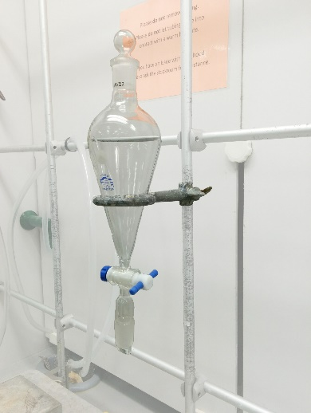  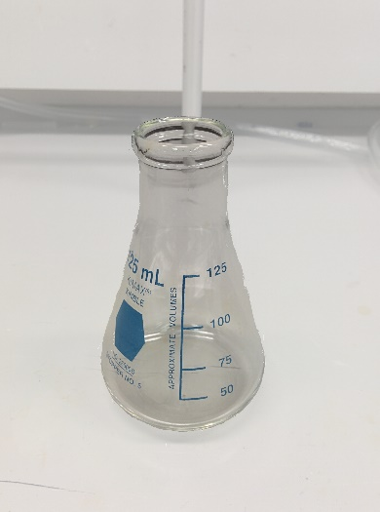 | - Make sure to use the ring stand for the seperatory funnel so that it does not tip over and break.  - Set up the seperatory funnel such that the bottom rests in the top of the recieving flask so as to avoid spills.

Procedure
- Place the seperatory funnel into a the ring stand and make sure the seperatory funnel is closed.
- Add 5 mL of 2-methyl-2-butanol to the seperatory funnel.
- Add 12.5 mL of concentrated HCl to the seperatory funnel and swirl to combine.
- Put the glass stopper on the seperatory funnel, and while holding the stopper one with a finger or two, carefully invert the seperatory funnel and vent immediately.
- Close the stopcock and vigorously shake the seperatory funnel for 20 seconds or so and then vent once again. Close the stopcock and repeat shaking and venting again.
- Place the seperatory funnel back into the ring stand, remove the glass stopper, and drain the bottom (aqueous) layer into an erlenmeyer flask.
- Add 10 mL of sodium bicarbonate solution slowly as gas will be produced. Swirl the seperatory funnel until the bubbling stops then put the glass stopper on, invert the seperatory funnel and immediately vent.
- Close the stopcock and shake the seperatory funnel ~ 20 seconds and the vent once again.
- Place the seperatory funnel back into the ring stand, remove the glass stopper, and drain the bottom (aqueous) layer into the same erlenmeyer flask containing the first aqueous extract (bubbling in the erlenmeyer may occur, so perform this second draining slowly). These aqueous extracts are waste, but do not dispose of them until you have completed the entire experiment.
- Perform a second wash (repeat the last 3 steps) but using sodium chloride solution this time.
- Perform a third wash with 10 mL of distilled water.
- Drain the organic layer into a clean erlenmeyer flask, add about 4 spatulas of anhydrous sodium sulfate, and swirl the flask for about 15 seconds.
- Pipet the liquid into a teared beaker and weigh to obtain the mass.
- Use a drop of the liquid to obtain the IR spectrum.
- Perform the silver nitrate and sodium iodide tests.

