**Procedure for Column Chromatography**

**Column Setup**

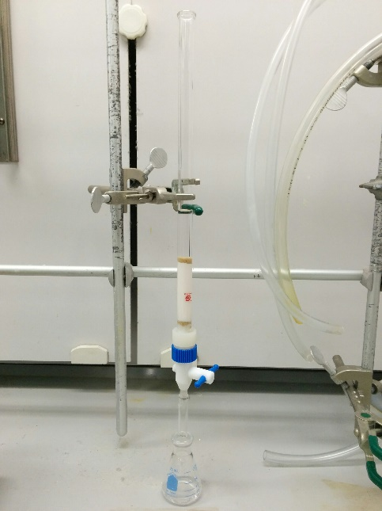

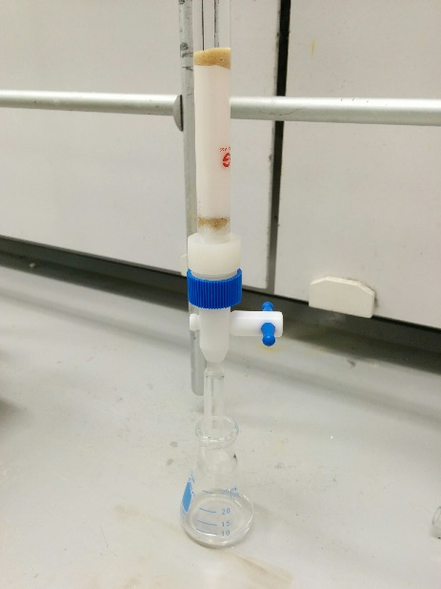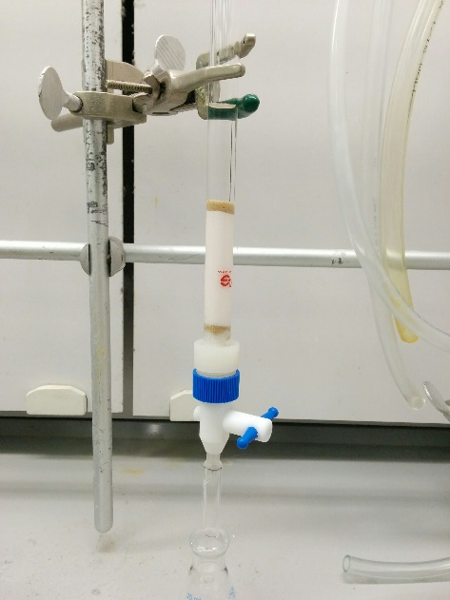

|  |
| --- |
| * Use a metal clamp to hold the column. * Be sure the column is as close to vertical as possible. * Place an Erlenmeyer flask below the bottom tip of the column such that the tip is a few centimeters lower than the rim of the flask. * Double-check that the column does not leak. Close the stopcock and add a few mL of petroleum ether. Look to see if any drops drain out of the column. If some does leak, tighten the nut on the back of the stop cock and try again. If the leak persists, ask your TA about swapping out your column. |
| * Roll a small piece of cotton into a ball and drop into the column. Open the stopcock and carefully blow air into the top of the column to ensure that the cotton is resting in the bottom of the column. * Add sand to the column such that the height of the sand is ~1 cm. Tap the column with your finger a few times to ensure that the top of the sand is flat. * Add 4 g of alumina to the column and tap the side of the column with your finger to ensure the top of the alumina is flat. * Add another 1 cm of sand to the top of the column. |
| * Slowly add ~20 mL of petreoleum ether to the column so as to not disturb the top layer of sand too much. * Open the stopcock and drain the liquid until it reaches the top of the sand, then close the stopcock. * Tap the column with your finger a few times to ensure the top of the sand is flat as well as to remove air bubbles from the column. |

**Procedure**

**Short story: run a column to separate two compounds.**

* Be sure that your column has been assembled properly.
* Carefully add one mL of the 1:1 mixture provided to the column so as not to disturb the sand layer (try to keep the layer flat and even). Drain until the liquid is just at the level of the sand (ie, the sand is still wet, but no liquid is above the sand).
* Wash down the internal wall of the column with ~1 mL of petroleum ether. Again, drain until the liquid is just at the level of the sand.
* Carefully fill the column with 20 mL of petroleum ether. Drain the liquid into an erlenmeyer flask. Stop draining once the top of the liquid reaches the sand.
* Add an additional ~5 mL of petroleum ether and drain into the same flask.
* Carefully add 20 mL of dichoromethane to the column and then drain into a clean beaker. Watch as the yellow band moves down the column and drains into the beaker as a yellow liquid. Take the last drop or so of the yellow liquid for your TLC plate (right and center positions, the center position is called a co-spot and should have one drop of the first componenet and one drop of the second component).
* Once all of the yellow color has left the column, the seperation is complete. You then need to check the effieciency of the seperation by running a TLC plate.
* Get one of the pre-cut TLC plates. Using a pencil, draw a horizontal line across the more narrow dimension about 2 cm from the end of the plate.
* Draw two small tick marks, evenly spaced, on this horizontal line.
* Take a glass spotter, provided in the lab, and dip into your first fraction. Touch the wet end of the glass spotter to the left tick mark of the TLC plate. Just one small spot will do.
* Do the same for the second fraction, but place your spots on the right tic mark. The TLC plate should have fraction 1 on the left, fraction 2 on the right, and both fractions in the middle.
* Find your glass jar and add about ~1 cm of petrolum ether.
* Carefully put the TLC plate in the jar with the tick marks at the bottom close to the liquid surface. Put the lid on the jar.
* Watch as the liquid rises up the TLC plate. Once the liquid line gets close to the top, remove the TLC and use you pencil to make where the liquid line is (do this relatively quickly because the line will disappear).
* Look at the TLC plate under the UV lamp and use a pencil to circle the spots that you see. Use a ruler to determine the retention factor of the two compounds.
* Take you Erlenmeyer flasks and heat them on your hotplate (~130 ºC) to evaporate the solvents.
* Weigh the solid products and observe their melting points.