The equipment setup for this lab will require the use of the following glassware assembled as shown:

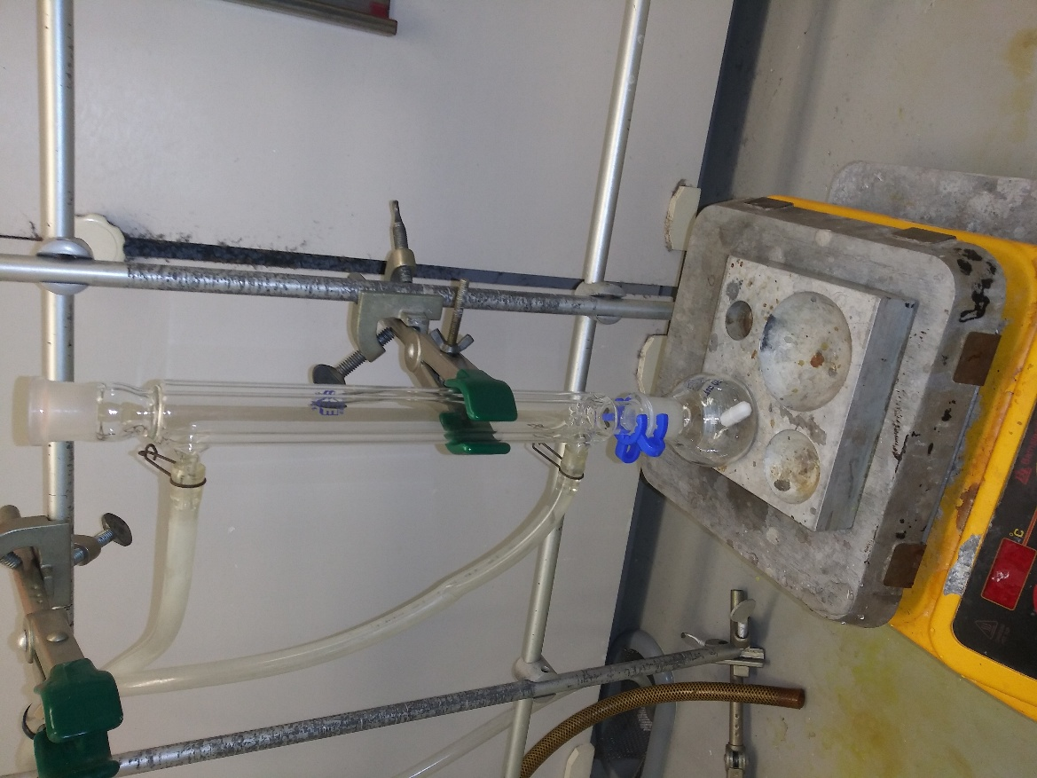 | - Center the 50 mL hole of the aluminum heating block as close to the center of the hot plate as possible. Place your one-inch stir bar into the 50 mL round-bottom flask and place the flask onto heating block. Attach your condenser to the round bottom flask securing it with a clamp. Place a Keck clamp between the round-bottom flask and the condenser.  - Attach the water-in hose at the bottom of the condenser and the water-out hose to the top of the condenser. Secure both hoses with the metal hose clamps. Slowly turn on the water until it begins filling up the condenser.

Bromination of E-Stilbene Procedure
- In a 50 mL round-bottom flask, add 0.36 g of (E)-stilbene and 10 mL of ethanol and your one-inch stir bar. Turn on the stir plate between 5 and 6. Turn on the hot plate to about 250 °C.
- Stir until most of the solid is dissolved and then add 10 mL of the 0.2 M bromine solution provided.
- Let stir for 20-30 minutes, or until most of the orange color has disappeared and a white solid has formed.
- Filter the precipitate using a Buchner funnel and wash the precipitate with ~ 2 mL of cold ethanol to ensure the removal of most of the bromine.
- Obtain the melting point of the product
- If 128K/120K,SAVE THE PRODUCT THE DEHYDROBROMINATION

