The equipment setup for this lab will require the use of the following glassware assembled as shown:

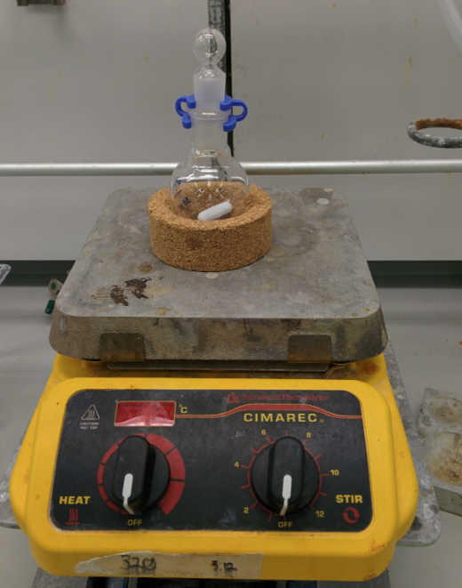 | - The procedure calls for lightly capping the reaction by resting the glass stopper on top of the keck clip. Make sure that the reaction is not sealed because you don't want pressure to build during the reaction; air should be able to flow around the stopper.  - It is advisable to clamp the round-bottom flask.

Bromination of E-Stilbene Procedure
- In a 25 mL round-bottom flask, add 0.9 g of (E)-stilbene and 10 mL of DCM and your rice stir bar.
- Stir to dissolve the solid and then add 5 mL of the 1 M bromine solution provided.
- Let stir for 10-15 minutes, or until most of the orange color has disappear and a white solid has formed.
- Filter the precipitate using a Buchner funnel and wash the precipitate with ~ 2 mL of cold DCM to ensure the removal of most of the bromine.
- Obtain the melting point of the product
- SAVE THE PRODUCT
  - 220C: FOR THE STOCKROOM!!!
  - 128K/120K: FOR THE DEHYDROBROMINATION

