The equipment setup for this lab will require the use of the following glassware assembled as shown:
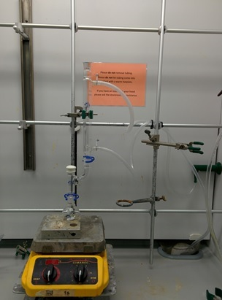 | - Do not forget to lightly grease all ground glass joints while setting up the apparatus or the glassware may seize together. Place a very small amount of grease on the male joint and then connect the glassware together and rotate them until the grease is spread evenly before securing it with a keck clamp.  - Ensure that every student uses the metal clips to secure the water hoses on the condenser. Water goes in at the bottom and out at the top; only a very slow flow of water is necessary. The water pressure can vary as more/less students turn it on. If the pressure gets too high the hoses will come off and flood the hood.
- There are multiple indentions on the heating block, make sure that they use the one that fits the round bottom properly. | 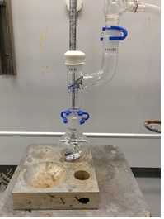

Grignard Procedure

Short story: synthesize benzoic acid and isolate from water
General steps students should follow:
- Very lightly grease the joints between the Claisen adapter and between the Claisen adapter and the condenser (which should be attached to the curved side of the Claisen adapter). Connect the water hoses to the condenser along with the hose clamps (please make sure that water goes in at the bottom and out at the top). Add rubber septum to the straight side of the Claisen adapter. Turn on water in condenser very slowly such that the rate is as slow as possible, but water is still flowing through the condenser. Lightly grease the male joint of the Claisen adapter and have it ready to connect to the round bottom flask.
- Add 0.5 g of Mg powder and one or two crystals of iodine to a clean and dry 50 mL round-bottom flask.
- Prepare a solution of 5 mL ether and approximately 2.5 mL of bromobenzene. Add 4 mL of this solution to the 50 mL round bottom flask.
- Add 5 mL of ether to the round-bottom flask.
- Using a glass rod, start grinding the magnesium power to the bottom of the flask until the solution turns cloudy. Quickly connect the round bottom flask to the Claisen adapter.
- Add the rest of the bromobenzene solution dropwise through septum using a syringe. It should take about 15 minutes to add it all. Let the reaction continue to mix for an additional 15 minutes or until the solution has turned a dark brown color.
- Crush 5 or 6 pieces of dry ice and add ~ 10 g of the pieces to a 125 mL Erlenmeyer flask (crush using the aluminum heating block).
- Pour the reaction mixture into the large beaker that contains the dry ice and swirl to mix thoroughly. Rinse the round bottom flask with 5 mL of diethyl ether and add it to the flask. Swirl the mixture in the flask for 5 minutes, and then set it down and let the excess dry ice sublime.
- While the dry ice is subliming, prepare a solution of 5 mL of sulfuric acid in ~5 mL of water. Add the sulfuric acid slowly to the water, and then place on ice until it is needed.
- Add the sulfuric acid solution to the reaction mixture slowly, there will be some bubbling as the excess magnesium dissolves. The ether volume should be about 25 mL. If it is below 25 mL, add more ether until it reaches 25 mL.
- Transfer the solution to the separatory funnel, you should be able to observe two clear layers (the top is ether the bottom is aqueous)
- Shake the separatory funnel (and vent) then drain the bottom aqueous layer (waste).
- Add 10 mL of sodium hydroxide solution, shake, vent, and drain the bottom aqueous layer (product!) Into a clean beaker
- Acidify the basic solution with 6 M HCl until the pH is ~1, white precipitate will form.
- Cool the beaker in an ice-water bath while you set up the Buchner funnel.
- Filter the solid product and wash with cold water.
- Save the product for the following week when you will obtain the molecular mass and melting point of your product.

Molecular Weight Determination by Titration

- Place 0.2 g of the benzoic acid into an Erlenmeyer flask that contains 25 mL of methanol.
- Once the solid has dissolved, add a drop or two of phenolphthalein solution.
- Using a Burette, titrate the solution with 0.1 M NaOH until the pink endpoint.
- Note the volume of the NaOH necessary to titrate the benzoic acid and then calculate the Molecular Weight of the benzoic acid.

