128L Engineers

ORGANIC CHEMISTRY LABORATORY

Spring, 2017
Section Page
- General Information 2
- Safety Information 2
- Attendance 3
Make-Up Policy 3
- Laboratory Protocol 3
Assigned Reading 3
Pre-Lab Quizzes 4
Lab Notebook 4
Samples 5
Chemicals 5
Due Dates for Reports 5
- Orientation 5
In-Lab Information 5
Library Information 5
- Check-In 7
- Grading Procedure 7
- Policy on Cheating 8
- TA Office Hours 9
- Faculty Course CoordinatorS 9
- Course Web Page 9
- Hints to Minimize Frustration IN ORGANIC CHEMISTRY 9
- Work Schedule 10
Lab Report Due Date Schedule 10
Experiments 10
- Supplements 14
  - Acetoacetate Reduction 14
  - Unknown Grignard List 16
  - Unknown Fischer Esterification 17
  - Nitration of a Substituted Benzene 19
  - Synthesis of Azo Violet 20
1. GENERAL INFORMATION

PRE- and CO-REQUISITES

Pre- and co-requisites for CH 128L listed in the Course Schedule. Important: Because the lecture and laboratory courses
are co-requisites of each other, dropping one of them requires that you drop the other as well, unless the drop occurs during
the final 2 laboratory periods of the term.

Pre- and co-requisites will be checked and students not meeting the requirements must drop the course.

REQUIRED or RECOMMENDED COURSE MATERIALS

- Experimental Organic Chemistry, Special UT 6th edition, by J. C. Gilbert and S. F. Martin, Saunders College Publishing, 2015 (Required). You must use the one sold at the coop.

- Lab Notebook: A “carbon copy” notebook with quadrille-ruled pages with page numbers. The recommended notebook will be sold by Student Affiliates of the American Chemical Society at the beginning of each term (Required).

- One Combination Lock: This must be a sturdy combination lock. UT Chem locks are available at the University Co-op. You MUST have them for check-in. Otherwise you will not be allowed to check into the laboratory until you have obtained the required locks. See p. 7 or this document for information regarding your responsibility for your equipment (Required).

- UT ID card: Bring your UT ID card to every laboratory session. It is needed to obtain items from the stockroom.

2. SAFETY INFORMATION **READ THE GENERAL SAFETY RULES ON THE WEBPAGE**

You are expected to follow all of the safety requirements in the course. Not following the safety rules could result in your removal from the lab and or the course.

CLOTHING

Street Clothes: Shorts or short skirts cannot be worn in the laboratory at any time, with or without a lab coat. Your shirt must at least have short sleeves and cover your torso, i.e., tank tops are not permitted.

Note: If you wear these to laboratory you will be sent home to change. On hot days you may wish to bring a pair of jeans or sweatpants to change into before entering the lab.

Shoes: Closed-toe shoes must be worn, i.e. sandals or clogs are not allowed.

SAFETY GOGGLES

The clear safety goggles provided by the department must be worn at all times in the lab. If your vision is corrected, wear your glasses under the clear safety goggles. Safety glasses are not permitted as substitutes for the goggles. Not wearing goggles in the laboratory may result in your expulsion for the remainder of the period.

LAB COATS

The blue lab coats provided by the department must be worn at all times in the lab. Wearing a lab coat does not excuse you from being properly dressed. Not wearing a lab coat will result in your being expulsion for the remainder of the period. The coat must buttoned all the way to the top and the sleeves need to be unrolled.

RADIO AND MP3 PLAYERS

Radios and MP3 players are not allowed in lab. This also includes your phones.
JEWELRY

It is strongly recommended that you not wear rings, bracelets, or watches to the lab. Such items can trap chemicals next to your skin, thereby worsening the effects of burns or allergic reactions. Also NOTE that the solvents used in this course may permanently mar the synthetic materials contained in watchbands and crystals!

3. ATTENDANCE

LAB LECTURE

Attendance at the laboratory lecture before your regularly scheduled laboratory period is required. This lecture provides some of the general "How To's of Organic Chemistry", and helpful hints on performing the experiments. It also correlates the laboratory experiments with the topics being covered in the lecture section. Much of this information is not written down anywhere; the only way to get it is from the lecture. Material discussed in the laboratory Lecture is also one of the primary sources of material for the quizzes in the course.

LABORATORY

Attendance will be taken at all laboratory sessions. You will not receive credit for any experiment scheduled for a laboratory period for which you have an unexcused absence. If you have an excused absence, you must obtain a makeup permit before you will be permitted to work in any of the labs outside of your own regularly scheduled laboratory period.

You must do all experiments by yourself unless otherwise specified. If you are found to have completed an experiment in a group without being instructed to do so by Dr. Fjetland (he is the only one who can grant this), then your grade for that experiment will automatically be assigned a “0.” This policy is also retroactive.

In some cases, data will be collected by groups of two or more students. Zero credit will be given if you are not present or did not participate in the experimental work. You are NOT PERMITTED to use data collected by others in the group work if you are not present at the time the work is done unless given explicit permission to do so by Dr. Fjetland.

MAKE-UP POLICY

Makeup Only excused absences may be made-up. Excused absences are those that are beyond your control, such as major emergencies and illness. Written verification of an excuse must be submitted for all absences, e.g., a doctor's note). To be eligible for a make-up laboratory period, you must request a permit for the make-up from Dr. Fjetland within one week of the excused absence.

A specific make-up day will be established for each experiment and that is the only day upon which the make-up work may be performed. You must have a make-up permit and must be on time to be eligible for the make-up lab.

There will be no exceptions to this policy!

Make-up reports are due when stated by Dr Fjetland.

4. LABORATORY PROTOCOL

ASSIGNED READING

Prior to each laboratory lecture, you should read the assigned pages of your text or any other assigned material.

PRE-LAB QUIZZES

A pre-lab will be given at the beginning of wet lab. The questions will be based upon the procedure and the theory of the experiment. It is strongly recommended so that you can use it to study for the quizzes. If you miss the quiz, you miss it. There will be no makeup quizzes given.

LAB NOTEBOOK

The laboratory notebook is a critical record of your accomplishments in the laboratory so you should treat it accordingly by making careful and complete entries in it. Your lab notebook must be written in ink. If an error is made, draw a single line through the error and then continue. Note that the original pages in your laboratory notebook should never be removed; rather, turn in the carbon copies of these pages as directed. The pages should be sequentially numbered and your name should appear at the upper right-hand corner of each page. Leave the first 2 pages of the notebook blank for future use as a TABLE OF CONTENTS. This notebook is the last line of defense if there are any problems with grades, which means DON’T THROW IT OUT.

Note: All prelab and postlab write-ups are to be done by yourself. Data interpretation and analysis are your individual responsibility and must also be done by yourself. Otherwise, the actions of the cheating policy (see Section 8) are applicable.

There is only 1 format for the laboratory notebook consisting of the following:

LAB PREPARATION

Lab preparation consists of reading the assigned material and writing a prelab report. The prelab report is hand written in ink in your notebook and will consist of the following:

- Heading: Use a new page of the notebook to start the entries for the experiment. Provide information that includes your name, the date, the title of the experiment, and a reference to the place in the laboratory textbook or other source where the procedure may be found. See page 7 of your laboratory textbook for an example.

- Purpose: Give a brief introduction to the experiment in which you clearly state the purpose(s) of the experiment. This should require no more than 5-8 sentences.

- Main Reaction(s) and Mechanism(s): Write a balanced equation giving the main reaction(s) for the conversion of the starting material(s) to product(s). If you are conducting a preparative type experiment, such as the synthesis of cyclohexene, the reaction that converts cyclohexanol to cyclohexene is given along with all the catalysts and conditions required (see page 10 of your textbook for an example). If you are conducting an investigative experiment where a reaction is being studied, such as the relative rates of bromination, the general reaction needs to be given (see page 528 of your textbook for an example).

- Procedure: Reference the source and page(s) of the procedure and include any changes that have been made.

- Safety Analysis: Safety is broken into three parts. The first part is identifying the have standard operating procedures (SOPs) that apply to the procedure we will be following. Simply list them in your notebook and also print them out so you have access to them in the lab. The SOPs are located on the course web page. The second part is conducting a hazard analysis for some given chemicals and/or equipment (a total of four). For each chemical and piece of equipment, you will be given a scenario. For each scenario, explain the potential danger it poses (ie: you will get very sick, have severe burns etc.), how to avoid it and finally how to rectify the situation (that is what do you do). The final part is printing the MSDS sheets for each chemical used for the given experiment. The MSDS sheets can be found on the web page.

POST LAB REPORT

The post lab report will consist of the following sections: (All sections are to be in your own words. Don’t copy anything!)

- Data and Results: Any observations that you make during the experiment belong here. This includes things like the color of the solution when mixed, how the reaction proceeded and what happened when you added a reactant. This section also includes the observed melting point, weight, and percent yield of the product. You must also put any and all spectra, TLC or other type of data in this section. (WRITTEN IN NOTEBOOK)

- Discussion: Discuss the theory behind the experiment performed and give a detailed mechanism of the reaction if one exists. The discussion should be about a page long. (TYPED)

- Data and Results Analysis: Analyze the data to determine what it means. Such as the purity of your product. This can be deduced from the melting point. A list of specific questions for your data analysis will be given to you for each experiment. (TYPED)

- Conclusion: Write a conclusion stating whether or not the experiment produced or did not produce the expected results. Also provide an explanation as to why or why not. The conclusion should be about half a page to a full page long. (TYPED)

- Post-Lab Exercises: Assigned post-lab exercises for a particular experiment are to be answered in your lab notebook in this section. They need to be placed after the conclusion section. (WRITTEN IN NOTEBOOK)

CHEMICALS

All reagents should be in your laboratory prior to the start of the laboratory period. These reagents will be located in the reagent hood. Solvents will be located in the solvent hood.

DUE DATES FOR REPORTS

The Prelab Report (Parts 1-5) is to be completed before the beginning of the laboratory specified in the Work Schedule. The TA will check and grade it to make sure that you have completed the preliminary report. It is your responsibility to make sure that the TA has checked and signed your prelab report. If you haven’t completed the prelab report when you walk into lab, you will not be allowed in until it is completed, and you will be deducted 100 % credit. Then you must complete the lab in the time remaining when you have finished the prelab report. If you do not finish the lab, you will not be allowed to make it up.

The Post Lab Report is due as specified in the Work Schedule and consists of parts 5-10. Your TA will sign the data section of your notebook after you have completed the experiment. It is your responsibility to make sure that your TA has signed your data section.

All Prelab and Postlab Reports are to be turned in to your TA at the beginning of the wet laboratory on the due date. Anything turned in after that time will be graded as late. Late Final Reports will receive 50% credit up to one week late. After one week, no credit will be accorded for the report. Submit the carbon copies of sections 1-6 and 10 and the printouts for sections 7-9. The typed report will be submitted to the Turn-It-In website to be checked and printed. The printed report will then be turned into your TA along with your data section. Information regarding Turn-It-In can be found on the webpage. Please ensure that you have printed the Turn-It-In report in the correct format, or it will not be accepted. Directions on how to print your report are on the webpage.

Make-up labs: All papers due at the missed laboratory period will be due at your next regularly scheduled laboratory period. Post lab reports for experiments completed in the make-up laboratory are due as directed by the instructor. The same penalties as given above for late submissions also apply here.

5. ORIENTATION

IN-LAB INFORMATION

On the first day of laboratory you will receive information from your TA on the various safety-related items in the room. It is important to know the location of these items as they may be needed in an emergency later on in the semester.

LIBRARY INFORMATION

There are a variety of sources in the Chemistry Library (WEL 2.132) that you may need to consult during this course. Some of the resources are listed below. The web address is as follows: http://www.lib.utexas.edu/chem/.

- CRC Handbook of Chemistry and Physics

Located on the Handbook Table, in many editions. Find the table in the CRC called “Physical Constants of Organic Compounds,” and look up your compound by name. Remember that a particular compound may go by many different names, so check synonyms! Older CRCs are quite different from newer ones in the way they are indexed and arranged; if you don’t find your compound in one, try another edition. The newest editions have useful formula, synonym and structural formula indexes after the Table itself. Abbreviations used in the Table are defined at its beginning. Do not use the index in the back of the CRC to find compound information. The CRC Handbook is now available on the Web.

- Merck Index

Also on the Handbook Table. This book contains information about common organic, inorganic, and biological substances, and has a Synonym Index in the back.

- Sigma-Aldrich Library of Chemical Safety Data

Two large black volumes located on the Handbook Table. Look up your compound name or its molecular formula (if you know it) in the Index in the back of Vol. 2. The entry will provide a structural formula as well as some physical data and hazard information.

- Reference Resource

A resource for finding references is the Web of Science link on the Mallet Library main web page. This will allow you to search many journal sources for a topic.

6. CHECK-IN

At the assigned laboratory period you will check into a drawer and hall locker that contain all your equipment. Anything that is missing or broken can be replaced free of charge during the CHECK-IN period. After this time, you will be responsible for all equipment and glassware. At check-out, drawers and lockers will be checked by the TA for broken or missing items, which you must be replace. Be aware that you are responsible for the safe storage of your equipment. Lost or stolen glassware will be reported to the UT Police and may be investigated by them.

To replace broken glassware or equipment, go to the stockroom with your student ID and purchase the needed replacements.
You will be sent a bill from the University for any such items.

You are required to check out of your drawer upon completing the semester or dropping the course (see below). A check-out fee plus a charge for missing equipment will be assessed if you fail to check out.

7. GRADING PROCEDURE

GRADING SCALE

This laboratory course uses the +/- grading scale. This grading scale has the following distribution:

Grade | GPA | Grade GPA Recommended % Range
A | 4 | 93-100%
A- | 3.67 | 90 - 92%
B+ | 3.33 | 88 - 90%
B | 3 | 82 - 88%
B- | 2.67 | 80 - 82%
C+ | 2.33 | 78 - 80%
C | 2 | 72 - 78%
C- | 1.67 | 70 - 72%
D+ | 1.33 | 68 - 70%
D | 1 | 62 - 68%
D- | 0.67 | 60 - 62%
F | 0 | Below 60%
FINAL GRADE DETERMINATION

Each laboratory section will be graded on an individual curve, and distributions will be posted periodically. TAs will be provided common guidelines for evaluation of reports. The final laboratory letter grade will be calculated as follows:

- A class curve may be established, and a letter grade will be assigned based upon final total score.
- To earn a C- or better in the course you must complete all assigned work and turn in all required reports.

REGRADES AND CORRECTIONS

Once an assignment has been returned, you will have one week to get an error corrected. After the week has passed, no regrades or corrections will be made on that assignment. The only exception to this is the correction of an error in the entry of the grade on the computer or an error in addition.

POINT DISTRIBUTION

What | Points
Prelab Report | 30 ea
Heading | 1
Introduction | 10
Reactions | 1
Procedure | 2
Safety SOPS  Hazard Analysis  MSDS | 2  12 (3 pts ea.)  2
Post Lab Report | 100 ea
Data and Results | 15
Discussion | 20
Data Analysis | 20
Conclusion | 10
Technique | 10
Post-Lab Exercises | 25
Quiz | 60

8. POLICY ON CHEATING FOR THE DEPARTMENT OF CHEMISTRY

The University of Texas at Austin expects honesty and integrity to be the ordinary way of life in all student activities.
Plagiarism, or the use of another person’s statements without giving proper credit, is dishonest and is regarded as cheating. Although group study and projects are often appropriate, it is expected that individual assignments and examinations will be the private efforts of the particular student. A student detected cheating beyond any reasonable doubt in the preparation of any individual assignment is subject to disciplinary action. See the General Information Bulletin.

The following are considered examples of cheating:

  - Copying raw data for a laboratory without actually participating in acquisition of the raw data.
  - Inventing data.
  - Filling in parts of laboratory reports that require the raw data for calculations or interpretation before the data are collected.
  - Holding discussions so thorough that they result in identical or nearly laboratory reports.
  - Allowing anyone to copy any laboratory report, either now or in the future.
  - Gaining access to, having in your possession at any time, or using old laboratory reports for any purpose. If you have questions regarding the format of any laboratory write-up, you should consult your TA or AI.
  - Gaining access to, having in your possession, using or distributing at any time grading rubrics.

PROPPER CITATION

To avoid plagiarism issues, it is best to never copy anything and to cite properly. For more information regarding proper citation, use the following links as resources

- http://deanofstudents.utexas.edu/sjs/acadint_avoid_ack_conv.php

- http://uwc.utexas.edu/

9. TA OFFICE HOURS

TAs will hold office hours in Welch 2.306 at times posted at this office, on the course bulletin board, or on the web page. Feel free to consult with any TA and to ask questions concerning either laboratory or lecture material.

It is Departmental policy that undergraduate students are not permitted in research laboratories. If you wish to consult your TA outside of his/her scheduled office hours, use e-mail and your TA will contact you.

10. FACULTY COURSE COORDINATOR

Dr. Conrad Fjetland
Office: NHB 1.128
Phone: 232-7676
crfjetland@cm.utexas.edu
Office hours: M 12-1, Th 11-12

11. COURSE WEB PAGE

A web page has been developed for the course. Among other things, it provides the course syllabus, a listing of office hours, and links to MSDS information and web pages, if any, for the various lecture sections associated with the lab sections. The URL is http://fjetland.cm.utexas.edu/courses/organiclab/.

12. HINTS TO MINIMIZE FRUSTRATIONS IN ORGANIC CHEMISTRY

Organic chemistry is one of the most exciting and challenging courses you will encounter at UT-Austin. The course encompasses a broad range of topics including petrochemicals, polymers, pharmaceuticals, and life-sustaining biochemical processes. Organic chemistry can bring immense pleasure and numerous rewards. Yet it may also foster frustrations, most of which involve time constraints. You may often feel overwhelmed by the sheer volume of material to be learned and the amount of work accompanying the demands of the laboratory. These are legitimate concerns. Much information is indeed covered, and considerable time is required both in and out of the laboratory itself.

There tend to be two major gripes that students have concerning the lab:

- Keeping a laboratory notebook and preparing for experiments require too much time.

Good science practices dictate that certain documentation be present in your laboratory book. Because we believe in teaching good science, this problem cannot be changed. With practice, you should become more efficient at preparing your laboratory book. A pointer: If you can’t find the necessary information (physical data, hazards) in a reasonable amount of time, don’t worry about it.

- Students feel rushed during the laboratory period.

To a certain extent, this is true. Most organic experiments involve several steps and techniques, one or more of which is often laborious and time-consuming. This is the nature of the beast. Nonetheless, organic experiments can be fun, especially if you can minimize frustrations. Fortunately, we have more control over time constraints during lab. Handling these problems is merely a matter of time management--making the most efficient use of your time in lab. To that end, the following suggestions should prove helpful:

- Come to laboratory prepared. This point can’t be overemphasized. People who know what they are doing before starting are far more efficient than people who must constantly refer back to a procedure to find out what they are going to do next. Advance preparation also lets you find any ambiguous points in the procedure. You can then ask to have these clarified during laboratory lecture.

- Start the experiment as soon as possible. This is usually not a problem. But you should be aware that you don’t have time to stop for a soft drink or to chit-chat on the way to the lab, if it occurs immediately following the laboratory lecture.

- Familiarize yourself with the location of frequently used chemicals and equipment in the lab. You will save time by not constantly having to ask where things are.

- Make the most efficient use of “dead time.” Many organic experiments have a stirring or reflux period during which there is nothing to do but wait. This time should be used for cleaning glassware and getting chemicals and/or apparatus ready for the subsequent steps. If there are qualitative tests assigned, they may be performed during such periods. These tests should not be done before starting the main reaction.

- Don’t presume that every reaction will work perfectly (or even at all). Often, these “tried and true” reactions fail to proceed the way the book describes. Even professional organic chemists with years of experience can’t get every reaction to work for them, despite the fact that the reaction may be cited extensively in the scientific literature.

- Clean your glassware before you leave lab. Like your pots and pans at home, laboratory apparatus is far easier to clean just after it is used rather than a week later. You will then be ready to start the next week’s experiment without delay.

- Remember that your TAs and AI are here to help you. If you have any problems or feel your frustration level rising, please don’t hesitate to talk to us. Here’s to a successful, enjoyable semester!
13. WORK SCHEDULE

LAB REPORT DUE DATE SCHEDULE*

Report | Due | Report | Due | Report | Due
Reduction | Period 4 | Fischer | Period 7 | EAS | Period 9
Grignard | Period 6 | Luminol | Period 8 | Azo Violet | Period 12
Kinetic vs Thermo | Period 6 | Aldol | Period 8 | Polymers | Period 12

* Final reports due at the beginning of wet lab. Be sure to submit to Turnitin.com

EXPERIMENTS

REQUIRED PRE-LAB PREPARATION! Read about the techniques listed at the start of each experiment in preparation for working in the laboratory.

Period: 1 | Date: 1-19

Due Today
Reading Assignments (due by lab lecture)
Sec. 1.1-1.11 and General Information in Syllabus
What Are We Doing Today? (In Wet Lab)
CHECK-IN

Period: 2 | Date: 1-26

Due Today
Reading Assignment
Secs. 17.1, 17.2, 17.4, 17.5 and supplement A
What Are We Doing Today?
REDUCTION OF METHYLACETOACETATE (Preparative)
(Procedure, miniscale, supplement A) (Product Analysis: IR, % Yield, Polarimetry)
(Post Lab Questions: pp 657-660, Problems 1, 3, 6)

Period: 3 | Date: 2-2

Due Today
Reading Assignment
Secs. 19.1–19.4, Supplement B
What Are We Doing Today?
ORGANOMETALLIC REACTIONS DAY 1: IDENTIFICATION OF AN UNKNOWN GRIGNARD (Preparative)
(Procedures, miniscale, pp. 719-721, and pp. 731-732) (Product Analysis: MP, MW)
(Post Lab Questions: pp 736-741, Problems 1, 4, 14)

Notes for Organometallic Reactions

- Lightly grease all joints.

- You will perform this reaction at ½ scale

- Obtain Unknown Bromide from Stockroom and use all of it.

- Plan to add 1 or 2 crystals of iodine, no more than that, prior to adding the bromide to the magnesium powder.

- The list of possible Grignard Unknowns is found in supplement B.

- Determine the unknown by mp and MW

Period: 4 | Date: 2-9

Due Today
Reading Assignment
CH 13, Supplement B
What Are We Doing Today?
ORGANOMETALLIC REACTIONS DAY 2: DETERMINATION OF EQUIVALENT WEIGHT
(Supplement B)

KINETIC AND THERMODYNAMIC CONTROL: FORMATION OF SEMICARBAZONES (Investigative)
(Procedures, pp. 448-451) (Product Analysis: MP) (Post Lab Questions: pp. 451-454, Problems 1, 7, 9)

Notes for Kinetic Control

- This experiment is to be performed by teams of two. One member is to do parts A, C, and E1, and the other is to do parts B, D, and E2. Note that the semicarbazones to be used in part E do not need to be completely dry.

- Determination of all MPs is to be done in Period 5.

Period: 5 | Date: 2-16

Due Today
Reading Assignment (due by lecture)
Secs. 20.1, 20.2 and Supplement C
What Are We Doing Today? (In wet lab)
ESTERIFICATION: IDENTIFYING UNKNOWN ESTERS PRODUCED BY FISCHER ESTERIFICATION (Preparative)
(Procedure, miniscale, pp. 771) (Product Analysis: GC) (Post Lab Questions: pp. 772-773, Problems 2, 3, 7)

Period: 6 | Date: 2-23

Due Today
Reading Assignment
Secs. 18.1, 18.3, 20.1 and 20.4
What Are We Doing Today?
ALDOL CONDENSATION: PREPARATION OF TRANS-p-ANISALACETOPHENONE (Preparative)
(Procedure, microscale, pp. 692-693) (Product Analysis: IR, MP, % Yield)
(Post Lab Questions: pp. 694-697, Problems 1, 3, 4)

CHEMILUMINESCENCE: SYNTHESIS OF LUMINOL
(Procedure, microscale, pp. 779 and 780) (Product Anlysis: Did it Glow)
(Post Lab Questions: pp. 780-784, Problems 3, 5, 6)

Period: 7 | Date: 3-2

Due Today
Reading Assignment (due by lecture)
Secs. 15.1, 15.4 and 15.5, Supplement D
What Are We Doing Today? (In wet lab)
ELECTROPHILIC AROMATIC SUBSTITUTION: NITRATION OF BROMOBENZENE (Preparative)
(Procedure, microscale, pp.522-523) (Product Analysis: GC, % o,p,m)
(Post Lab Questions: pp. 524-528, Problems 1, 5, 9)

ELECTROPHILIC AROMATIC SUBSTITUTION: RELATIVE RATES OF REACTION (Investigative)
(Procedure, pp. 533-534 (part 1)) (Product Analysis: Relative rates of Reaction)
(Post Lab Questions: pp. 536-540, Problems 3, 7, 8)

These are to be written as one Report

Notes for Rates of Reaction

- Predict the order of reactivity before you come to lab and have that prediction in your notebook.

Notes for Nitration

- You will work in groups of 4. Each person in the group nitrates their own bromobenzene.

- Weigh out 0.02 g of each crude nitrated product within the group and dissolve in 10 mL dichloromethane.

- Shoot 2 µL of the crude solution.

- Refer to the table in supplement D for retention time information

Period: 8 | Date: 3-9

Due Today
Reading Assignment
Sec 21.1, Supplement E
What Are We Doing Today?
MULTISTEP SYNTHESIS (AZO VIOLET) DAY 1: PREPARATION OF N-ACETANILIDE (Preparative)
(Procedure, miniscale, pp. 805-806) (Product Analysis: IR, MP, % Yield)
(Post Lab Questions: pp. 810-814, Problems None)

Notes for Multistep

- Save a little of each sample as direct for individual analysis.
- Do it at ½ scale

Period: 9 | Date: 3-23

Due Today
Reading Assignment
Supplement E, Sec 21.1
What Are We doing Today?
MULTISTEP SYNTHESIS (AZO VIOLET) DAY 2: PREPARATION OF 4-NITROACETANILIDE
(Procedure, miniscale, Supplement E) (Product Analysis: MP, IR, NMR, % Yield)

Period: 10 | Date: 3-30

Due Today
Reading Assignment
Supplement E, Sec. 21.1
What Are We Doing Today?
MULTISTEP SYNTHESIS ( AZO VIOLET) DAY 3: PREPARATION OF p-NITROANILINE
(Procedure, miniscale, Supplement E) (Product Analysis: IR, MP, NMR, % Yield)

Period: 11 | Date: 4-6

Due Today
Reading Assignment (due by lecture)
Sec. 15.6, Supplement E , Secs. 22.1, 22.2, and 22.3

PreLab Exercises
Sec. 15.6 Azo Dyes (pl 83-84) 1-3
Sec. 22.2 Preparation of Polystyrene (pl 121-122) Problems 4,8
Section 22.3 Preparation of Nylon-6,10 (pl 123-124) Problems 7-10
What Are We Doing Today? (In wet lab)
PREPARATION OF A DYE: AZO VIOLET (Preparative)
(Procedure, Supplement E) (Product Analysis: Dyeing analysis, pH affect)

PREPARATION OF POLYSTYRENE (Preparative)
(Procedure, miniscale, Part C, 861-862) (Post Lab Questions: pp. 864-866, Problems 6,8,10)

PREPARATION OF NYLON-6,10 (Preparative)
(Procedure, alternative, pp. 871-872) (Post Lab Questions: pp. 872-873, Problems 1,10,11)

Note: The polymer experiments are to be written as 1 report

Period: 12 | Date: 4-13

What Are We Doing Today? (In wet lab)
CHECKOUT

14. SUPPLEMENTS

A. Reduction of Methyl Acetoacetate

Reduction of a carbonyl compound using sodium borohydride will typically yield the racemic mixture. For most undergraduate teaching labs, this result is perfectly acceptable. However, in some areas of the synthetic world, in particular the pharmaceutical arena, there are needs to produce one isomer. Many chiral reducing agents have been developed but they are usually too expensive for the undergraduate lab. Nature has a variety of reducing enzymes, Glutathione Reductase being one, but working with enzymes can also be difficult in undergraduate teaching labs.
One method to produce a specific isomer is to introduce the chiral molecule tartaric acid to the reduction reaction. The tartaric acid forms a complexe with the sodium borohydride during the reduction. In essence, it acts similar to an enzyme.

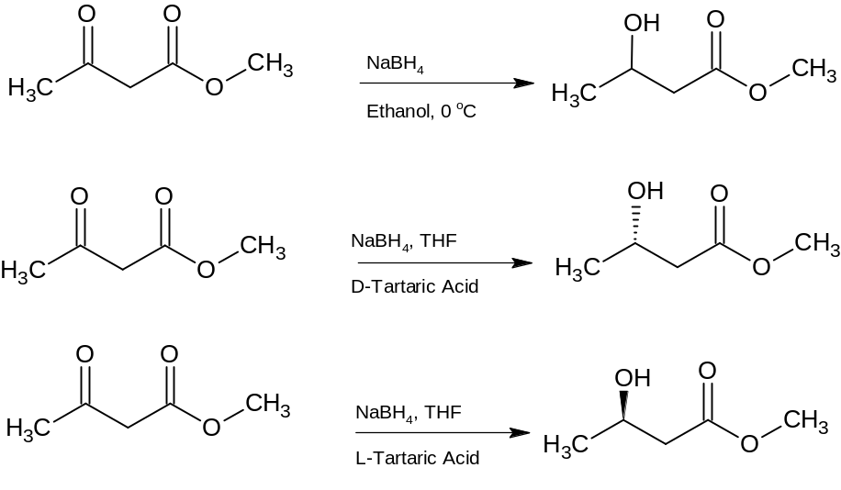

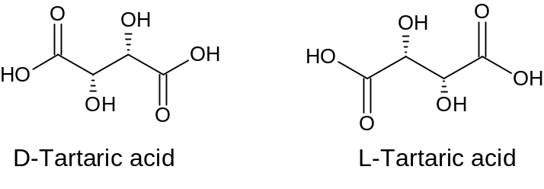

14. SUPPLEMENTS (CONT.)

Racemic reduction of methyl acetoacetate

Place 1.5 g of sodium borohydride and 25 mL of 100% ethanol in a 250 mL beaker with a one inch stir bar. To this mixture add a solution of 5 g of methyl acetoacetate in 15 mL ethanol. Stir the reaction while heating it to a gentle boil. When all the ethanol has evaporated (this can be facilitated by blowing air across the top of the beaker), remove from the hotplate.
Place the beaker in an ice-water bath and slowly add 30 mL of 1 M HCl to quench the reaction (CAUTION: This may result in the release of hydrogen gas, so add drop-wise at first). Add 30 mL of dichlormethane and swirl until dissolved.
Add the mixture to a separatory funnel and collect the organic layer. Dry it completely with sodium sulfate and filter. Remove the dichloromethane by blowing it dry. Obtain an IR spectrum of the product, calculate a percent yield and observe the optical rotation.

Chiral reduction of methyl acetoacetate with L or D tartaric acid

Add 0.5 g of sodium borohydride and 2.0 g of D or L tartaric acid to 30 mL of THF in a 100 mL round bottomed flask with a one inch stir bar. Stir for 15 minutes and cool in an ice bath. Add 0.4 mL methyl acetoacetate using a 1 mL syringe. Stir in the ice water bath for two hours. Next add 10 mL of 1 M HCL dropwise with a pipet with continued stirring. After the addition is complete, remove from the ice bath and stir at room temperature for 10 minutes.
Extract the solution with 25 mL of diethyl ether in a separatory funnel. Wash the diethyl either with 20 mL of saturated sodium bicarbonate and collect the organic layer and then 20 mL saturated sodium chloride. Dry the organic layer with sodium sulfate and filter it. Remove the ether by air drying it in the hood. Obtain an IR spectrum of the product, calculate a percent yield and observe the optical rotation (dissolve 25-30 mg into 0.75 mL dichloromethane).

References

- Pohl, N.; Clague, A. and Schwarz, K, J. Chem. Ed. 2002,79, 727-728
- Yatagai, M. and Ohnuki, T. J.Chem. Soc., Perk. Trans. 1 1990
14. SUPPLEMENTS (CONT.)

B. List of Grignard Unknowns

Compounds For Grignard Reaction

Name | Structure | MW | MP (°C)
benzoic acid | 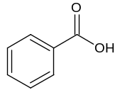 | 122 | 122
2-methylbenzoic acid | 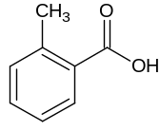 | 136 | 104
3-methylbenzoic acid | 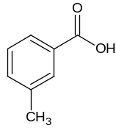 | 136 | 111
4-methylbenzoic acid | 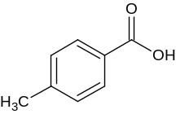 | 136 | 180
2-ethylbenzoic acid | 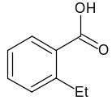 | 150 | 62
3-ethylbenzoic acid | 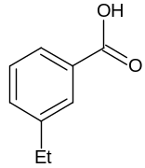 | 150 | 47
4-ethylbenzoic acid | 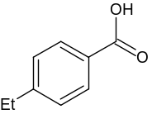 | 150 | 112
2,6-dimethylbenzoic acid | 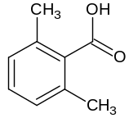 | 150 | 114
2,5-dimethylbenzoic acid | 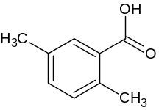 | 150 | 132
2,4-dimethylbenzoic acid | 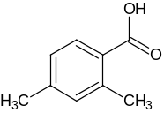 | 150 | 123

14. SUPPLEMENTS (CONT.)
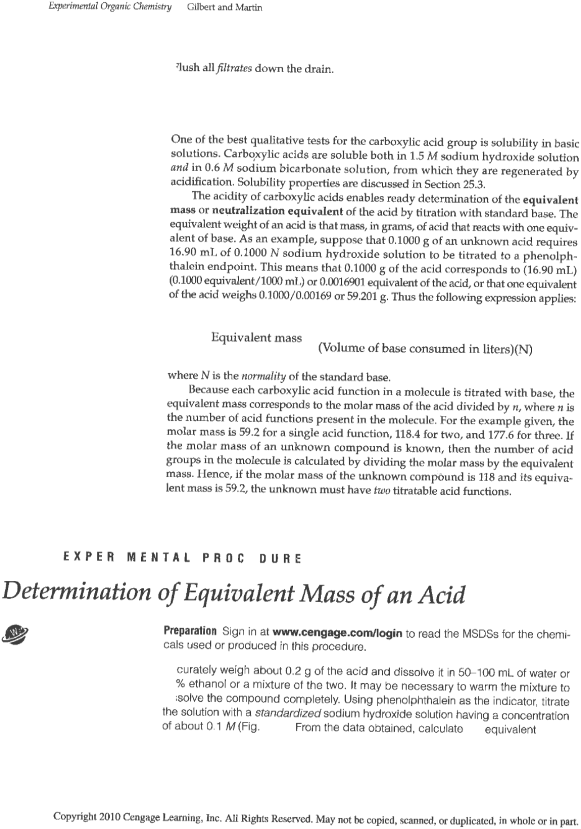
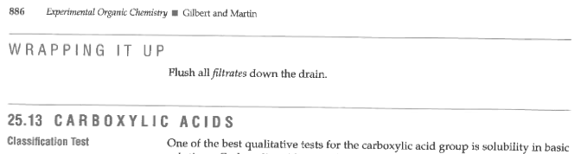

14. SUPPLEMENTS (CONT.)

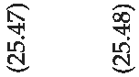


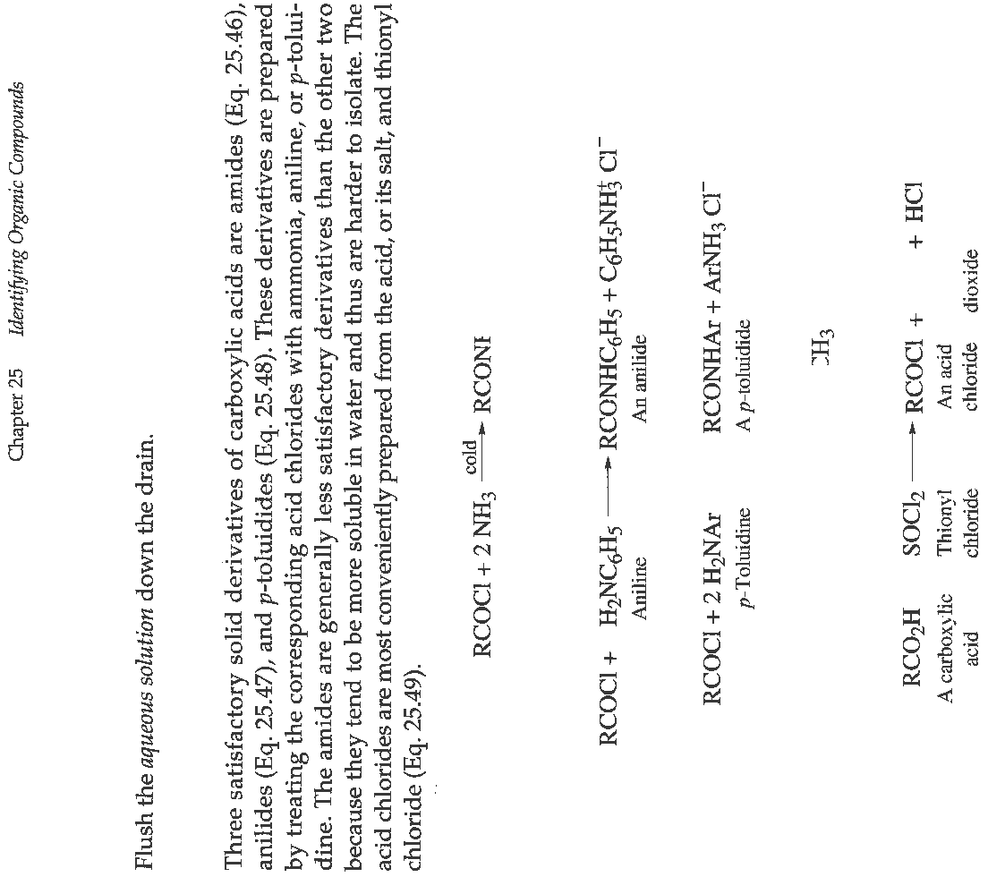


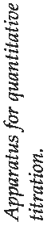
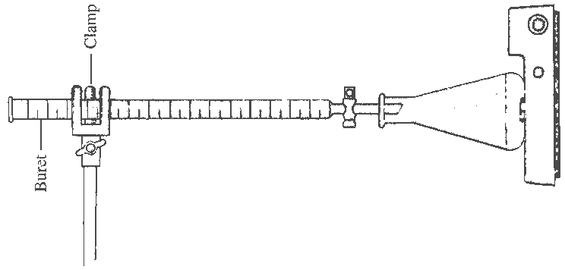
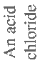

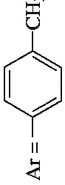






14. SUPPLEMENTS (CONT.)

C. GC Retention Times of Unknown Esters

TABLE __ RETENTION TIMES & GC METHODS

ESTER | METHOD A | METHOD C
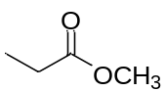  Methyl propionate | 6.55 | 3.01
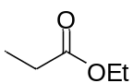  Ethyl propionate | 9.96 | 4.64
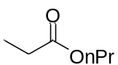  n-Propyl propionate | 14.68 | 7.52
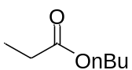  n-Butyl propionate | 18.88 | 9.29
 | METHOD B
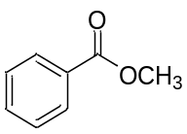  Methyl benzoate | 1.24 | 11.82
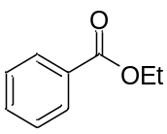  Ethyl benzoate | 1.71 | 12.47
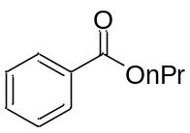  n-Propyl benzoate | 2.24 | 13.28
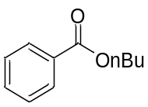  n-Butyl benzoate | 3.38 | 13.70

14. SUPPLEMENTS (CONT.)

D. GC Retention Times of Nitrated Arenes
Retention Times of Nitrated Standards

Compound | Rt (min)
bromobeneze | 8.35
chlorobenzene | 6.05
2-chloronitrobenzene | 18.74
3- chloronitrobenzene | 17.87
4- chloronitrobenzene | 18.25
2-bromonitrobenzene | 21.18
3-bromonitrobenzene | 20.60
4- bromonitrobenzene | 20.88

14. SUPPLEMENTS (CONT.)

E. Preparation of Azo Violet

Humans have been using dyes since prehistoric times. Plants were the source of the dye material up until the last century. Plant roots, leaves and berries were boiled in water to extract the dyes. The art of dyeing cloth was a complicated process often requiring mordants (heavy metal salts) to fix the dye to the fabric. One of the oldest known dyes is madder, which is today called alizarin. Madder is a very brilliant red dye that comes from the madder root. A similar dye to alizarin is called henna, which has long been used in the coloring of human hair to redheads.

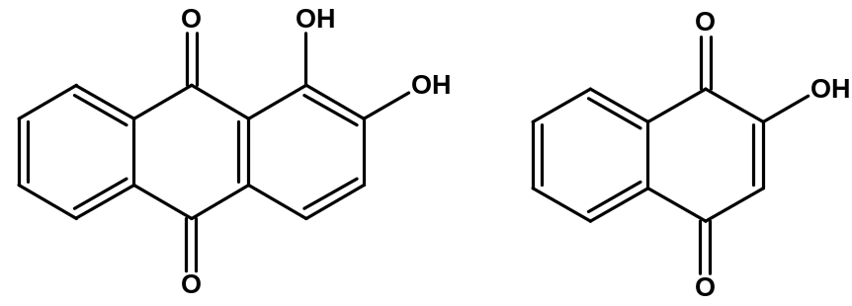

Alizarin Henna

Indigo is another ancient dye from the plant Indigofera tinctoria. Asians have been using it for more than 4000 years by extracting it from the leaves of the indigo plant. However, today the dye is synthetically made. Until 1856, all dyes were extracted from natural sources. However, William H. Perkin, an English chemist, in an attempt to synthesize quinine from allyltoluidine, synthesized Perkin’s Mauve, the first synthetic dye. His discovery led to the production of pararosaniline, malachite green and crystal violate which are in a group called the triphenylmethyl dyes.

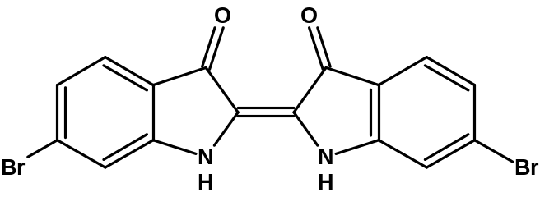

Indigo

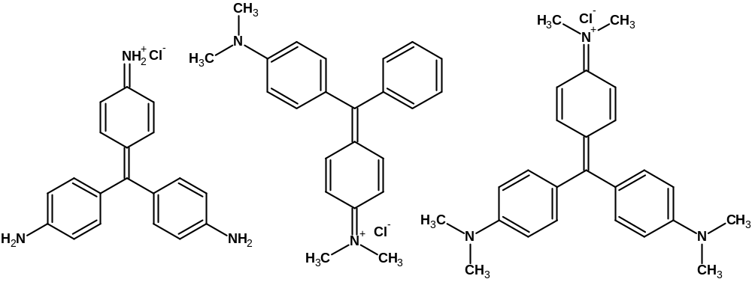

Pararosaniline Malachite green Crystal violet
Today, the most common dyes are called the azo dyes, which are formed from aromatic amines to phenols and other aromatic amines. They are called azo dyes because they contain a nitrogen-nitrogen double bond, which is called an azo group. The reaction first involves the formation of diazonium ion from the aromatic amine by adding nitrous acid in process called diazotization. Next, the phenol or amine is added in a reaction called diazonium coupling.

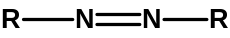

Azo group

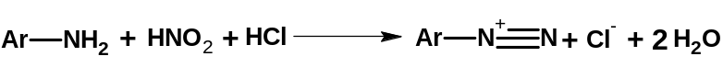

Diazotization

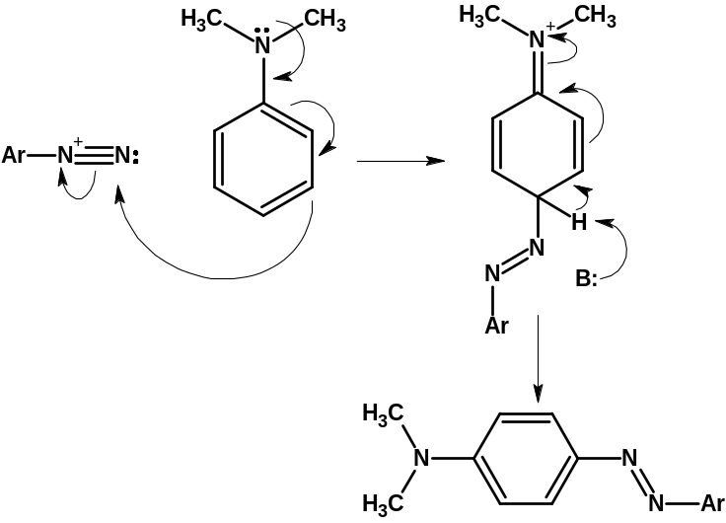

Diazonium Coupling

In the following experiment, you will be synthesizing azo violet (2,4-dihydroxy-4’-nitroazobenzene). The overall synthesis is an example of of a multi-step synthesis. The synthesis involves several steps (five) starting with aniline (see Scheme 1). We could however, increase it to seven steps if we decided to start with benzene instead of aniline (see scheme 21.2, page 702 of the text). However, since aniline is a readily available chemical, and benzene has some serious hazard issues, we are starting with aniline. The formation of acetanilide is an example of a protection reaction and is done to make the formation of p-nitroaniline much easier. By acetylating aniline, we decrease the the reactivity of the amine. Amines are strong ortho/para directors. If left unaltered, we would end up with a mixture of the ortho and para product as well as some multi-nitrated product. The acetyl group prevents this by being too bulky to allow for the formation of the ortho product, though we do end up with a little. The acetyl group also ties up the lone pair of electrons in the amine through resonance, making the dinitration products less likely. Thus, the predominant product is the p-nitroacetanilide requiring a simple step to remove the small amount of ortho that is produced.

Following the synthesis of p-nitroacetanilide, we deprotect to produce p-nitroaniline. We can now proceed to the synthesis of azo violet. First we perform the diazotization product of p-nitroaniline. Next, we run the diazonium coupling reaction with resoricinol (1,3-dihydroxybenzene). With a little cleanup, we are left with azo violet. Since azo violet is a dye, our analysis will be determining if the product can indeed dye some fabric. It is also used as a pH indicator, so we will test it for different colors in different pH’s.

Scheme 1

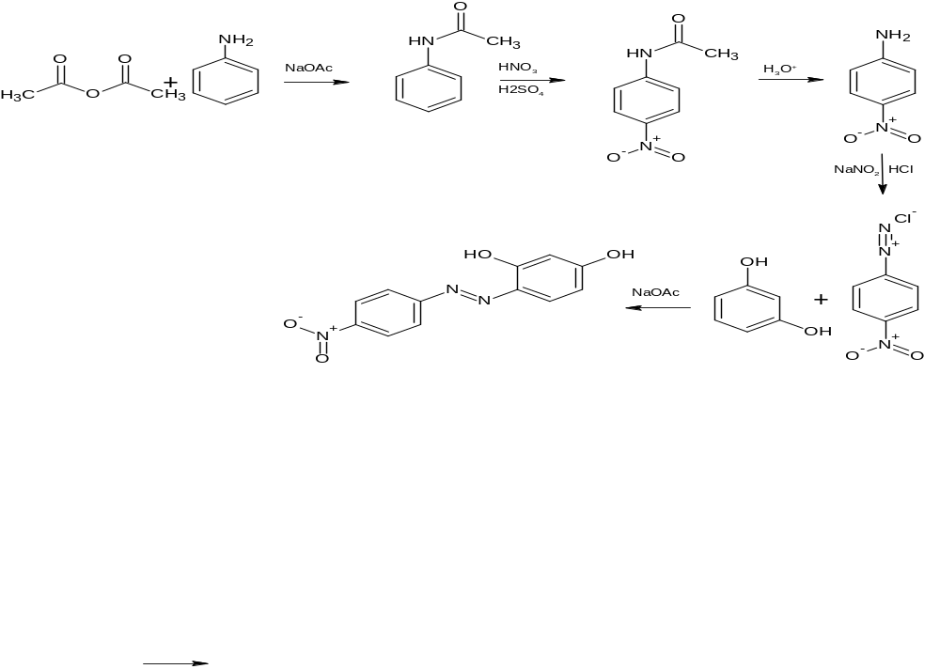
PROCEDURE

Acetanilide
See page 805-806 of the text. Conduct at half scale

p-Nitroacetanilide: Add 1.0 g of acetanilide to 5 mL glacial acetic acid in a 25-mL Erlenmeyer flask. Carefully pour 5 mL concentrated sulfuric acid into the mixture while stirring constantly. After the acetanilide has dissolved, place the flask in an ice-salt bath and cool it to 5°C. Prepare a solution of 2 mL concentrated nitric acid and 1.3 mL concentrated sulfuric acid. While stirring the acetanilide solution, add dropwise the nitric/sulfuric mixture at a rate such that the temperature does not rise over 20°C. After the addition, let the mixture stand at room temperature for 20 min. Pour the reaction mixture into 25 mL of cold water with 15 g of ice. Collect the solid that forms by vacuum filtration and wash the solid with three 30-mL portions of cold water. Recrystallize the solid from 95% ethanol. Save a small amount for analysis (mp, nmr).

p-Nitroaniline: Add 0.74 g of p-nitroacetanilide and 5 mL of water to a 25 mL round bottom flask. Slowly add 5 mL concentrated sulfuric acid while swirling. Reflux the mixture for 30 min. Cool the reaction mixture and pour the contents into a mixture of 15 g ice in 20 mL water. Slowly with stirring add 9 M sodium hydroxide until the pH of the mixture reaches 4-5. Cool the mixture in an ice bath and collect the precipitate by vacuum filtration. Wash the solid four times with 20 mL portions of water. Save a small amount for analysis (mp, nmr).

Diazonium salt: Prepare a solution of 0.072 g p-nitroaniline in 2.7 mL concentrated hydrochloric acid and 10 mL of water in a 25 mL Erlenmeyer flask. Place in an ice water bath. Once the solution is cooled, add a solution of 0.035 g sodium nitrite in 1.5 mL water dropwise while stirring. When finished adding the sodium nitrite solution, continue stirring at 0-5º C for 15 minutes.

Azo Violet: Prepare a solution of 0.055 g resorcinol in 8 mL methanol in a 125 mL Erlenmeyer flask and place the solution in an ice water bath. While stirring, slowly pour in the diazonium salt solution. Continue stirring at 0-5º C for 30 minutes and then neutralize to a pH of 5-6 with sodium acetate solution. Allow the solution to mix for 30 minutes. Isolate the product by vacuum filtration and rinse with cold water.

Dyeing Test: To a 30 ml beaker add 50 mg recrystallized product, 0.5 ml of 1 M sodium sulfate, 15 ml water and 5 drops of 1 M sulfuric acid and mix thoroughly. Bring the solution close to the boiling point and place a small piece of cotton into the solution for 5 minutes. Remove the cotton, allow it to cool and the rinse thoroughly water (use the sink and tap water). Allow the cotton to dry and then compare it to undyed cotton.

Indicator Test: Place a few crystals of the dye into three test tubes. Next add a few drops of 0.5 M HCl to one tube and a few drops of 0.5 M NaOH to one test tube until the color changes. To the third test tube add a few drops of water. Note the different color changes for each solution.

REFERENCE

- Mohrig, J.R.; Morrill, T.C.; Hammond, C.N.; Neckers, D.C. Experimental Organic Chemistry; Freeman: New York, NY, 1997; pp 456-67

- D. Sek, E. Grabiec and A. Miniewicz, Polymer Journal, 35, 749-756, (2003)

