How To Submit Your Labs to turnitin.com

- Login and click on the title of your course.
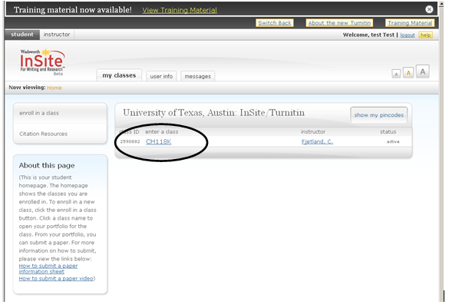
- Click on the submit button next to the lab assignment you need to submit.

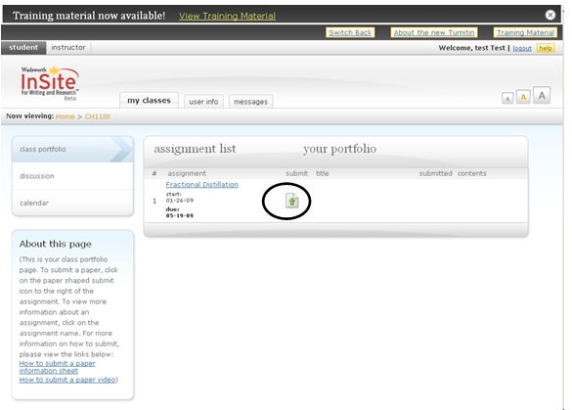

- The drop down menu is set to file upload by default. Do not change this setting. Fill in the title of your lab report and then click Browse to attach your lab. Once you’ve attached the correct lab, click submit.
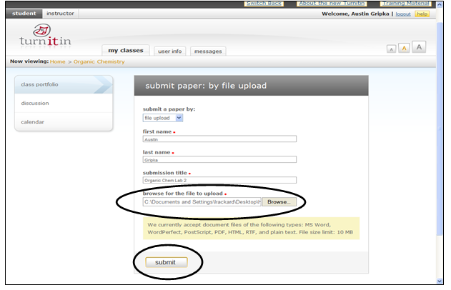

- Preview the lab and then click Submit Paper. If you’ve attached the wrong lab, click Cancel, go back. If you attach the wrong lab and click Submit Paper, your instructor will need to clear your lab report and grant you another submission.
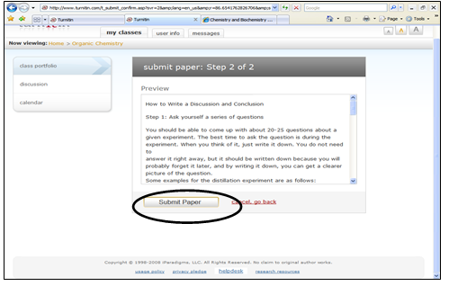

- View your digital receipt and click (go to your portfolio).
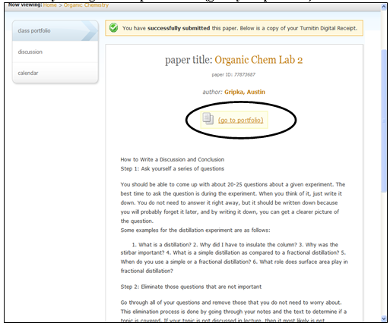

6. Click on the view button to the right of the desired report.
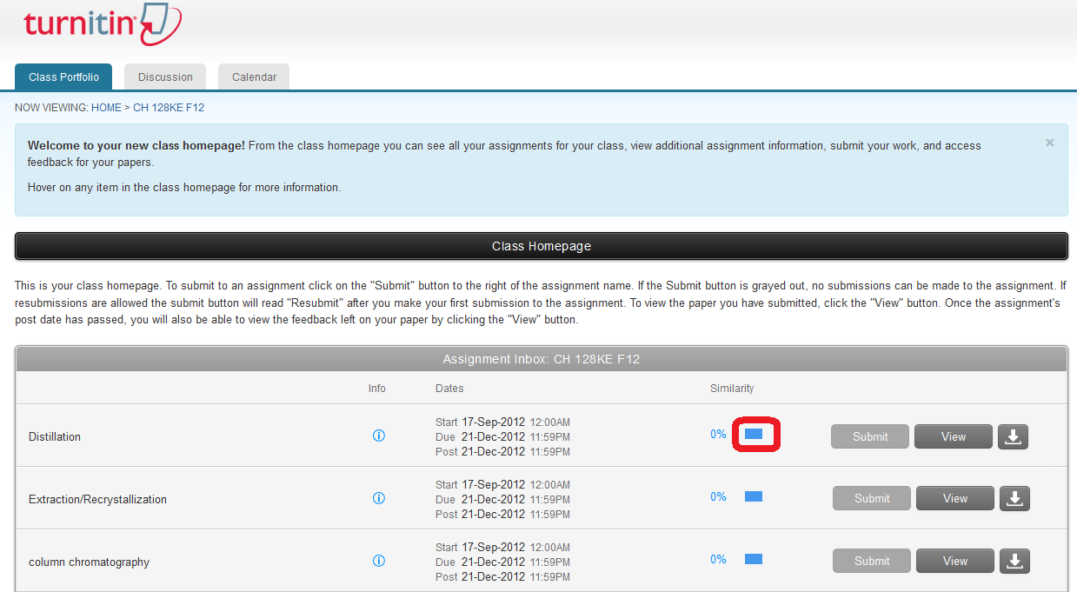
7. Select the Download Button on the right of the screen

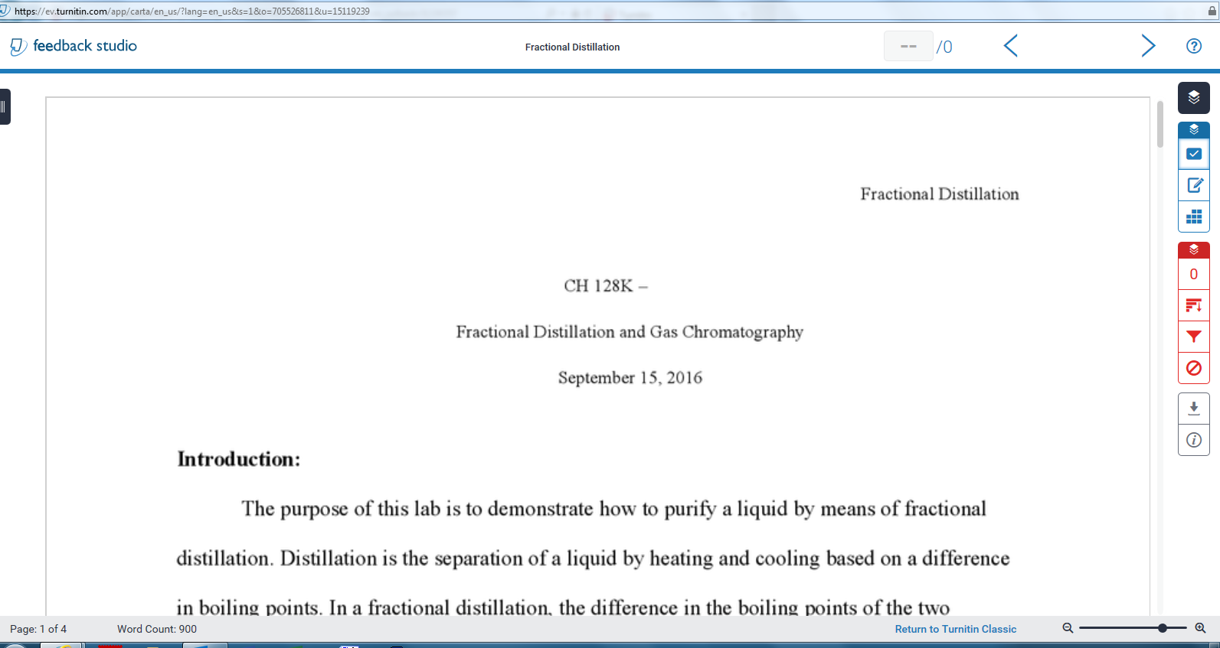

8. Click on the Current View.


9. When prompted, Open the pdf and print.

9. Print your lab and turn it in to your TA.

